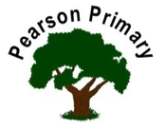
Writing |  | In writing this half term, Year 6 will be writing a diary entry from the perspective of Anne Frank. The children have done a lot of wider reading around her life in both reading and history lessons to support their writing.  The children will also be completing a writing assessment on a short animation to assess what they have learnt so far in year 6. |  |  |  | Maths |  |  |  | Reading
 |  |  |  |  |  | In maths this half term our focus is calculation. We will be exploring addition, subtraction, multiplication and division in more detail alongside prime numbers, square and cubed numbers and roman numerals.  The children will also complete a weekly arithmetic in preparation for their upcoming KS2 SATS in May. |  |  |  | This term we will continue reading our class read ‘Letters from the Lighthouse’ - a fictional story set during WW2. The children will also explore several non-fiction texts to support understanding in their history and geography lessons and be asked to rehearse, perform and re-cite a poem.
Science  In Science, the children are exploring electricity and will be getting hands on in a practical activity creating their own circuits. This knowledge will be used next half term when the children make a moving car in D&T with a working circuit attached. |  |  |  |  | Personal, Social, Health and Economics (PSHE)  The school’s Jigsaw theme this half term is ‘celebrating me’. |  |  | 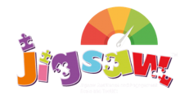 | Geography  In Geography, year 6 are learning about the 6 major biomes, their location, how they are being destroyed and how we can protect them in the future.
 |  |  |  |  | This half term the children are exploring how ‘difference’ can be a cause for celebration but also a cause of conflict. The children will look at what makes a diverse society and reflect on their attitude towards those who are ‘different’.
D&T |  |  |  |  | Religious Education  This half term, Year 6 will focus on three key religions: Christianity, Islam and Humanism, exploring the key question ‘Is it fair?’ in relation to the topic ‘Justice and Freedom’. The children will look at the power of reconciliation and forgiveness and understand the ways in which people experience injustice and how they can overcome it.  We will also complete a four-week Christmas unit. |  |  |  | Computing  In computing, we will explore online safety in more detail. The children will learn how to identify secure websites and build on their knowledge from previous year groups about how to keep themselves safe on the internet.
In D&T, the children will be adapting a traditional pasta sauce recipe and making their own pasta dish with an accompanying bread. The children will learn about nutritional value and the impact of different food groups.

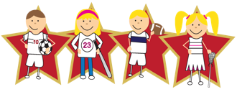 |  |  | Physical Education  Our PE day is on Thursday. Our PE unit this half term is dance. |  |  |  | Languages (Latin)  This half-term, we will continue our Latin journey through the Maximum Classics scheme of work. The focus will be verbs.

