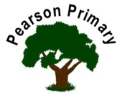
Writing |  | This half term in writing we will be writing a setting description for a narrative based on the book ‘Crater Lake’ and our class residential to PGL. We will also be writing a diary entry in the style of Anne Frank. |  |  |  | Maths |  |  | 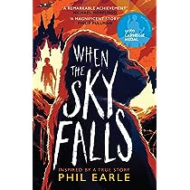 | Reading
 |  |  |  |  |  | In Maths, our primary focus will be number. We will be looking at place value in detail as well as the four operations: addition, subtraction, multiplication and division. |  |  |  | This term, our main class read is ‘When the sky falls’ by Phil Earle; an adventure mystery book set during World War 2. Our focus non-fiction text will be extracts from Anne Frank's Diary and our end of the day read will be chosen by the children to promote a love for reading.
Science  This half term in Science, Year 6 will explore light and electricity. The focus for working scientifically will be pattern seeking and conducting a fair test. |  |  |  |  | Personal, Social, Health and Economics (PSHE)  The school’s Jigsaw theme this half term is ‘Being me in my world’ |  |  | 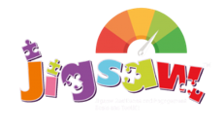 | History  In year 6 this half term, the children will study World War Two. Children will write an evaluative statement answering the question ‘What caused the second world war and what were the local affects?’
 |  |  |  |  | This half term, the children will start their year 6 Jigsaw programme and understand their rights and responsibilities in the year 6 classroom as well as thinking about their aspirations for the upcoming year and beyond.
Art  In Art, our focus is portraiture. The children will build on their skills from previous year groups and time spent with an artist in Year 5 to produce a self-portrait conveying an emotion of their choice. |  |  |  | 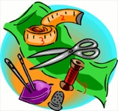 | Religious Education  This half term, Year 6 will focus on three key religions: Christianity, Islam and Humanism, exploring the key question ‘Is it fair?’ in relation to the topic ‘Justice and Freedom’. The children will look at the power of reconciliation and forgiveness and understand the ways in which people experience injustice and how they can overcome it. |  |  |  | Music  In Music, Year 6 will be exploring film music in more detail. The children will play tuned and untuned instruments, use their bodies for percussion and listen to music and match their composition to the mood of the piece.
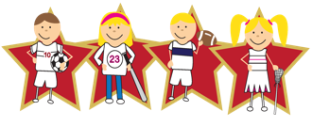 |  |  | Physical Education  Our PE day is on Wednesday. Our first PE unit is ‘athletics’ where the children will learn how to perform a range of jumps and throws in various competitions and challenges. |  |  |  | Languages (Latin)  This half-term, we will continue our Latin journey through the Maximum Classics scheme of work.

