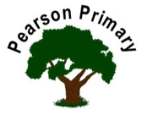
Writing |  | Narrative  This half term the children are innovating texts inspired by picture books from our classroom bookshelves. We will be investigating how figurative language, emotive language and imagery makes a narrative effective. |  |  | 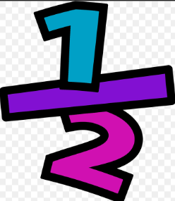 | Maths |  |  | 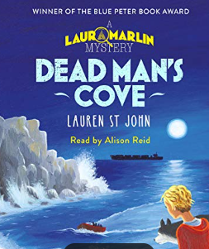 | Reading
 |  |  |  |  |  | This term we are further developing our multiplication and division skills by looking at multiples, factors, square and cube numbers and prime numbers. We will also be tackling fractions through fluency and reasoning based questions. |  |  |  | This term we will be reading Dead Man’s Cove. We will practise a range of skills such as retrieval and inference. We will use clues from the text to discuss how the characters feel and make more predictions as more mysteries are revealed…
Science  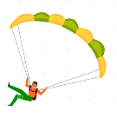  We will continue to work on Forces and carry out experiments on air resistance and friction. |  |  |  |  | Personal, Social, Health and Economics (PSHE)  The school’s Jigsaw theme this half term is ‘Celebrating Difference’. |  |  | 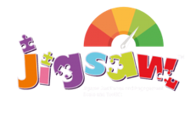 | Geography  We will be exploring Longitude and Latitude and answering questions such as ‘why do we have 24 hours in a day?’ and ‘what is the Prime Meridian?’ We will be investigating answers to these questions through the use of globes and atlases.
 |  |  |  |  | This half term we will be looking at our own culture and comparing this to others from different parts of the world. We will be discussing whether difference is positive and tackling issues such as racism and bullying.
DT |  |  |  | 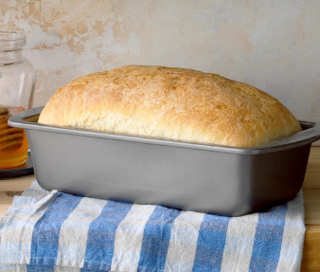 | Religious Education  Our three principal religions are Christianity, Islam and Judaism.  We will be learning about Peace and Christmas  The key question that we will explore is:  Peace around the world? |  |  |  | Computing  Pupils will be learning about E-Safety throughout this half term. This will include ‘stranger danger’ online and cyber bullying.
This half term we will be designing and baking our own healthy bread.
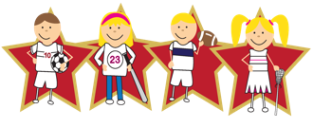 |  |  | Physical Education  Our PE day is on Thursday. |  |  |  | Languages (Latin)  This half-term, we will continue our Latin journey through the Maximum Classics scheme of work. We are focusing on root words and will be moving onto verb endings just before the winter break.

