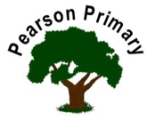
Writing |  | This term we will be exploring tension writing and writing non-fiction texts using a range of literary features. We cannot wait to see the pupils’ imagination shine through their written pieces. |  |  | 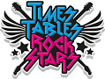 | Maths |  |  | 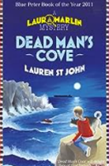 | Reading
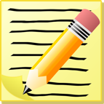 |  |  |  |  |  | This half term we will be working on place value and addition and subtraction using a range of resources. Please remember to continue practising Times Tables on TT Rock Stars. |  |  |  | This term we will be reading Dead Man’s Cove. Whilst this is our lead text we will still be reading a range of other fiction, non-fiction, poetry and picture books to supplement our learning.
Science  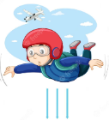  This half term we will be investigating the role of forces in everyday life. We will be looking at gravity, air resistance, friction and more! We will be carrying out investigations and experiments inside and outside of the classroom! |  |  |  |  | Personal, Social, Health and Economics (PSHE)  The school’s Jigsaw theme this half term is ‘Being me in my world’ |  |  | 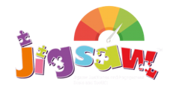 | 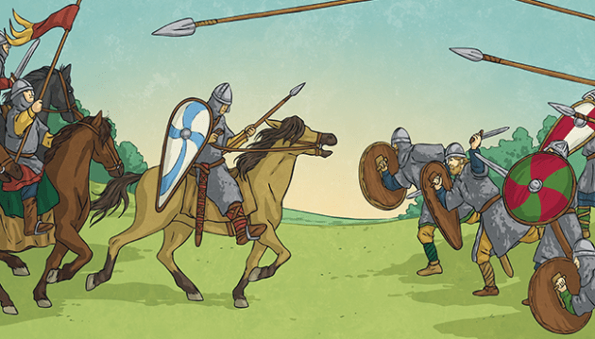  History  This half term we will be investigating ‘How did the Anglo-Saxons and Vikings battle for the kingdom of England and how did their rule come to an end?’ We will be using a range of historical sources to find plausible answers.
 |  |  |  |  | We will be looking at different aspects that make up our identity.
Art |  |  |  | 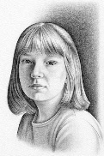 | Religious Education  Our principal religions this half term are Christianity, Islam and Humanism.  We will be learning about Expression.  The key question that we will explore is: How is belief expressed? |  |  |  | Music  This term we will be using the music programme ‘Kapow’ to explore beats and rhythms that represent the Ancient Egyptians.
This term we will be working towards creating self-portraits using a range of materials.
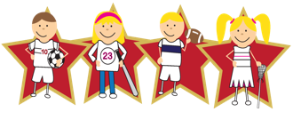 |  |  | Physical Education  Our PE day is on Friday. |  |  |  | Languages (Latin)  This half-term, we will continue our Latin journey through the Maximum Classics scheme of work.

