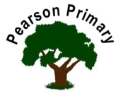
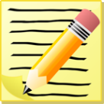  Writing  We will be writing a narrative using a video clips as a stimulus.  We will write a setting description based on abandoned places. |  |  |  | Maths  We will be finishing place value then focussing on addition and subtraction. We will be practising our times tables to prepare for the Multiplication Test that the children will sit at the end of the school year. Please use TT Rockstars to support with this. |  |  | Reading
 |  |  |  |  |  |  | This term we will be reading ‘’Mr Penguin and the Lost Treasure’ as well as an assortment non-fiction texts that will support our other lesson. We will also continue reading ‘Baby Aliens Ate my Teacher’ during story time.
Science  As scientists, we are learning about electricity and experimenting with some electrical circuits. We will be identifying how we can make a bulb light and explore what effect changing our circuit will have on the brightness of the light. |  |  |  | Personal, Social, Health and Economics (PSHE)  The school’s Jigsaw theme this half term is ‘changing me’. |  | 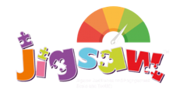 | Geography  This half term we will be learning about water cycles and rivers with a focus on Europe.
 |  |  |  | This half term we will be looking at what it means to celebrate difference. We will be exploring the influence different groups can have on us and how we can celebrate and accept everyone’s differences.
DT  We will be exploring and adapting biscuit recipes to make our own biscuits. |  |  |  | Religious Education  Our principal religions this half term are Christianity and Islam.  Our linked religion is Judaism.  We will be learning about symbols of faith.  The key question that we will explore is:  What are the special symbols of the Christmas story? |  |  | Computing  This half-term we will be working ‘unplugged’ to focus on how children can keep themselves safe online and how we can maintain a healthy balance of screen time.
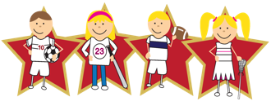 |  | Physical Education  Our PE day is on Wednesday, please ensure your child has their kit in school every day in case the weather means we have to change. Please leave it in school for the whole half term. |  |  | Languages (Latin)  This half-term, we will continue our Latin journey through the Maximum Classics scheme of work.

