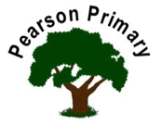
Writing |  | During Writing we will be focussing on basic skills. We will write a character description and build to writing a narrative. |  |  | 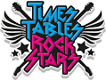Maths  This term we will look at Place Value, using numbers up to and beyond 1000. We will also focus on out multiplication facts. |  |  | Reading  This term we will be reading ‘Mr Penguin and the Lost Treasure.’ We will also read a selection of non fiction extracts.
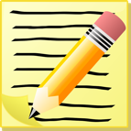
Science  We are going to be investigating ‘Sound’ this half term. We will find out how sound is made and how it travels. |  |  |  |  | Personal, Social, Health and Economics (PSHE)  The school’s Jigsaw theme this half term is ‘Being me and my world’ |  | 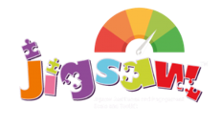 | History  Our topic this term will be ’The Roman Empire and its impact on Britain.’ Through this we will be focussing on cause and consequence.
Design Technology |  |  |  | 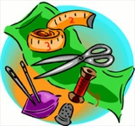 | Religious Education  Our principal religion this half term is Christianity.  Our linked religion is Islam.  We will be learning about ‘Communities’.  The key question that we will explore is:  Where is religion? |  |  | Music  We will be having weekly music lessons with Mrs Farmery every Thursday. We will look at rhyme, rhythm and tempo.
Our focus will be food technology where we will design, make and evaluate a biscuit.
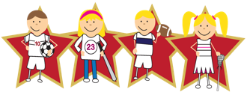 |  |  | Physical Education  Our PE day is on Tuesday. |  |  | Languages (Latin)  This half-term, we will continue our Latin journey through the Maximum Classics scheme of work – The origins of language.

