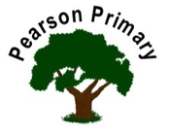
Writing |  | In our writing lessons we will be writing narratives. We will continue to develop our editing and improving skills. |  |  |  | Maths |  |  |  | Reading
 |  |  |  |  |  | We continue to learn new methods when completing addition and subtraction problems. We will be looking at problem solving and inverse operations. |  |  |  | This term we will be continuing reading The Great Chocoplot.
Science  As scientist we will continue our learning about how rocks and fossils are formed. We will be classifying and sorting them according to their properties and uses. We will carry out investigations to see which are hard wearing. |  |  |  |  | Personal, Social, Health and Economics (PSHE)  The school’s Jigsaw theme this half term is ‘celebrating difference’. |  |  | 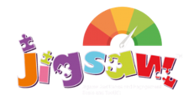 | Geography  We will be looking at the UK, using maps, atlases and globes to identify different locations.
 |  |  |  |  | This half term we will be learning about families and how every family is unique.
DT  In our DT lessons we will be learning about healthier choices and preparing a healthier option sandwich. |  |  |  |  | Religious Education  Our principal religion this half term is Christianity.  Our linked religion is Islam  We will be learning about Forgiveness and faith leaders. |  |  |  | Computing  We will be looking at computer science, coding and flowcharts.
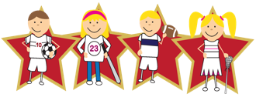 |  |  | Physical Education  Our PE day is on Monday. We will become gymnasts in our lessons and visit a fully equipped gymnastics gym to use some of the skills we learn. |  |  |  | 