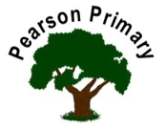
Writing |  | In writing this half term we will be focusing on our basic skills and presentation. We will be writing descriptions of the characters from the stories we read. |  |  |  | Maths |  |  | 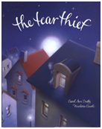 | Reading
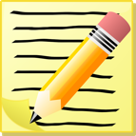 |  |  |  |  |  | We will be focusing on our place value understanding of numbers to 1000. We will be checking our knowledge of multiplication facts for 2,5,10 and 3 then learning the facts for 4. Please use TT Rock stars to support with this. |  |  |  | This term we will be reading The Tear Thief. We will then be moving on to read The Great Chocoplot. We will be focusing on making predictions about our texts.
Science  As scientist we are learning about how rocks are formed. We will be classifying and sorting them according to their properties and uses. We will carry out investigations to see which are hard wearing, which are permeable and impermiable. |  |  |  |  | Personal, Social, Health and Economics (PSHE)  The school’s Jigsaw theme this half term is ‘Being me in my own world’ |  |  | 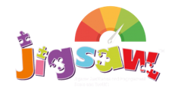 | History  We will be learning about the Stone Age to the Iron Age. We will assess our understanding of the chronology of the time periods and ensure we know the key achievements of each of them.
We will be looking at what it means to ‘be me in my world’ and how it applies to our children.
We will be establishing our class charter and holding each other to account to ensure we have our learning environment as we want it.
Art  We will be developing our drawing skills. Drawing portraits inspired by Amrita Sher-gil. |  |  |  | 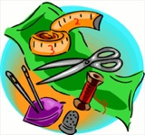 | Religious Education  Our principal religion this half term is Christianity.  Our linked religion is Islam.  We will be learning about Rememberance.  The key question that we will explore is:  What does it mean to remember? |  |  |  | Music  We will be singing ballads and building our musical vocabulary as we prepare our performance.
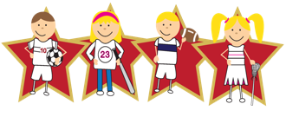 |  |  | Physical Education  Our PE day is on Monday, please ensure your child has kit in school every day in case the weather means we have to change. |  |  |  | We are excited to learn!

