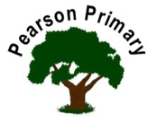
Writing |  | We will be writing a non chronological report about different animals and a story based on Mog’s Christmas Calamity. |  |  |  | Maths |  | 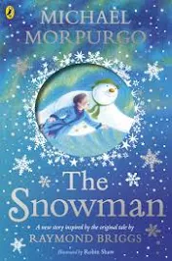 | Reading
 |  |  |  |  |  | Our focus will be fluency of addition and subtraction facts. We will be challenging ourselves to complete daily recall tasks efficiently! |  |  | This term we will be reading ‘Grandads Giant and ‘The snowman’
Science  Our topic is ‘Living Things and their Habitats.’ We will learn how to sort things into living, dead and never been alive. We will also look at different types of habitats and how animals are suited to them. |  |  |  |  | Personal, Social, Health and Economics (PSHE)  The school’s Jigsaw theme this half term is ‘changing me’. |  | 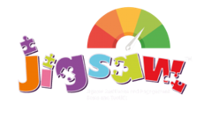 | Geography  We will start with map work, identifying our country and others in the UK. We will then look at weather patterns across the UK.
 |  |  |  |  | This half term we are looking at differences between boys and girls, particularly looking at stereotypes.
Design and Technology |  |  |  |  | Religious Education  Our principal religion this half term is Christianity.  Our linked religion is Sikhism.  We will be learning about Temptation.  The key question that we will explore is:  Right or Wrong? |  |  | Music  Our music will be focussed around our KS1 nativity. We will focus on singing skills such as keep to time and volume.
We are focussing on our textile skills. We will create a winter shape to bring home. Focusing on using our running stitch.
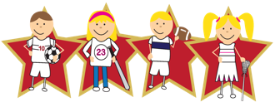 |  |  | Physical Education  Our PE day is on Tuesday. This half term we are developing our dance skills and the linked vocabulary.

