Writing |  | As writers this half term we will consolidate all we learned in year 1. We will be using capital letters and full stops, extending some sentences with conjunctions and using adjectives to make our writing more interesting. |  |  |  | Maths |  | 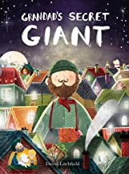 | Reading
 |  |  |  |  |  | During our maths lessons we will be securing our understanding of place value. We will be learning and using vocabulary to explain our thinking in maths. Our focus times table is 2. |  |  | This term we will be reading Grandads Secret Giant. We will learn to retrieve information independently.  We will continue to develop our reading skills and fluency during daily phonics sessions.
Science  As scientists we will study animals, including humans. We will learn about animal survival, food and our own hygiene.  We will make comparisons and sort using given criteria. |  |  |  |  | Personal, Social, Health and Economics (PSHE)  The school’s Jigsaw theme this half term is Being me in my world. |  | 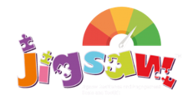 | History  As historians we will be learning why remembrance is significant. We will use sources of evidence and discuss our thoughts and findings with each other.
 |  |  |  |  | This half term we will learn about ourselves and how to look after ourselves in the world we live in.
Art |  |  |  |  | Religious Education  Our principal religion this half term is Christianity.  Our linked religion is Islam.  We will be learning about making choices.  The key question that we will explore is:  Lead us not into temptation. Right or wrong? |  |  | Music  During our music lessons this half term we will be using our voices and developing as singers. We will also have some music lessons with the wider opportunities team and develop our understanding of making music with others.
This half term we will be developing our drawing skills.

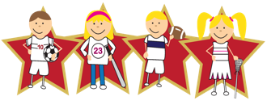 |  |  | Physical Education  Our PE day is on Thursday. We will be learning about and developing our Athletics skills.  Please send a PE Kit and leave it in school for the half term, if the weather permits, we will continue to do outdoor PE and therefore it may be on a different day.

