 | Curriculum Newsletter – Class 1 – Autumn 2023
Writing |  | We will be writing instructions on making simple sandwiches.  We will retell the story The Elephant and the Bad Baby.  We will revisit writing labels and captions with Where’s My Teddy.  We will focus on writing well punctuated sentences, and including adjectives for describing. We will begin to use the conjunctions AND and BECAUSE to extend sentences. |  |  |  | Maths |  | 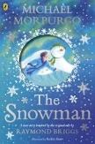 | Reading
 |  |  |  |  |  | We will develop adding and subtraction, and look at how they are linked as Fact Families. We will identify, describe and group 3D and 2D shapes.  We will count on in 2’s and begin to recall facts for the 2 x table. We will also count on in 5’s and 10’s. And forwards and backwards to 20. |  |  | This term we will be reading ‘Lighthouse Keeper’s Lunch’, ‘Elephant and the Bad Baby’, ‘The Three Little Pigs and the Big Bad Book’, and ‘Where’s My Teddy’.  Please listen to your child read at home 3 times every week – and jot a note in their Reading Record book.
Science  Our topic is ‘Seasons’ - we will begin our Seasons work by identifying the signs of Autumn, and comparing Autimn with Summer.  We will talk about how animals, plants and the weather change from Summer to Autumn. |  |  |  |  | Personal, Social, Health and Economics (PSHE)  The school’s Jigsaw theme this half term is ‘being me’. |  | 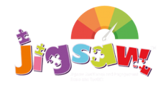 | Geography  We will focus on our Local Area. Children will write their address, and find their home on a local map. We will then explore our local urban area, identifying the key features nearby.
 |  |  |  |  | This half term we are looking at differences and similarities between all of us, celebrating those similarities/differences. We’ll explain what Bullying is.
Design and Technology |  |  |  |  | Religious Education  Our principal religion this half term is Christianity.  We will learn about the Christian festival of Christmas, and discuss the important festivals of another religion - Islam. |  |  | Computing  Children will log on to a device and become familiar with using a device to type, edit pictures and save.
We are focussing on Food Technology. Children will design and make a Fruit Kebab - cutting safely and appropriately, and thinking about nutrition and food origins.
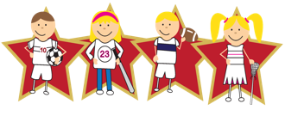 |  |  | Physical Education  Our PE day is on Tuesday. This half term we are developing our dance skills and the linked vocabulary.

