Writing | Based on Rainbowfish:  - Labels and Captions  - Character Descriptions  Based on Lighthouse Keeper’s Lunch:  - Instructions  Based on Elephant and the Bad baby:  - Story writing |  |  |  |  | Maths |  |  | Reading
 |  |  |  |  |  | Place Value of numbers up to 10.  - One more. One less & Ordering.  - Representing numbers in different ways.  Adding/Subtracting  - Representing these calculations visually – parts and wholes.  - Writing “number sentences”  - Fact Families.  - Bonds TO ten & Bonds WITHIN 10  - Adding. |  |  | This term we will be reading…  Rainbow Fish; Jes Aldborough books including Where’s My Teddy, Hug, and My Friend Bear; and The Lighthouse Keeper’s Lunch.  Children will bring their phonics reading books home every day. They will get two new books for home each week.  Please make sure books come back to school EVERY DAY.  *We may ask that any lost or damaged home reading / phonics books be paid for.
Science  Animals including humans:  - Names of human body parts.  - Identify and explore the 5 senses.  - Body parts linked to senses. |  |  |  |  | Personal, Social, Health and Economics (PSHE)  The school’s Jigsaw theme this half term is ‘relationships’ |  | 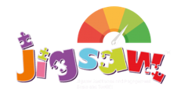 | History  What was my local area like in the past?  - Learning what past/present means.  - Identifying items/photos from the past and present day.  - School in the past/present.  - Pearson Park in the past/present.
 |  |  |  |  | This half term
Design Technology |  |  |  |  | Religious Education  Our principal religion this half term is Belonging  Our linked religion is ISLAM |  |  | Computing  Being Digitally Literate:  - Logging in and using a username/password.  - Saving documents/media.  - Retrieving and using saves files.  - Creating pictures and saving, for later editing.
Food technology: preparing fruit kebabs
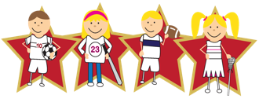 |  |  | Physical Education  Our PE day is Monday.  However, some weeks this may change, so have kit in school EVERY DAY and leave it in school.  Kit this term – outdoor: trainers, shorts, T-shirt, and jumper/joggers if it’s chilly.  Please write your child’s name in all of their clothes.

