Long Term Reading Overview
Year Group | Autumn Term |  | Spring Term |  | Summer Term
The Tree-house | Julia Donaldson –  Zog  Room on the Broom  Gruffalo  Stick man  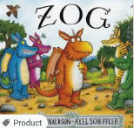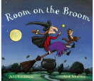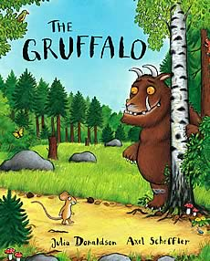 |  | Traditional tales-  Goldilocks and the three bears  Little Red Hen  The Three Billy Goats Gruff  Jack and the Beanstalk  The Three little pigs  The Ginger bread man  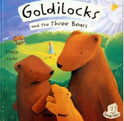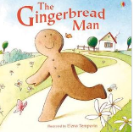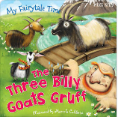 |  | The tiger who came to tea  Handa’s hen  Handa’s surprise  Giraffes can’t dance  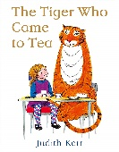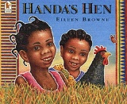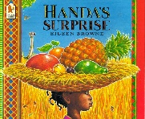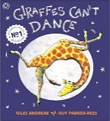
 | Additional Texts to compare:  Meg and Mog (similarities and difference)  I see Winter-  The snowy day |  | Additional Texts to compare:  The Ghanaian Goldilocks  Mr men- maths text(shape) |  | Additional Texts to compare:  Where the wild things are (does Max have super powers?)
 | Non – Fiction  Season Books  Cookery books | Poetry  Cat's Cook Book  Red leaves, yellow leaves  Maths rhymes and poems | Non - Fiction  Growing – bean plants  Where food comes from  Bridges  Cookery books | Poetry  Maths rhymes and poems | Non – Fiction  People who help us  Tigers  Wild animals | Poetry  Maths rhymes and poems  Farm animals

Year Group | Autumn Term |  |  | Spring Term |  |  | Summer Term
EYFS | 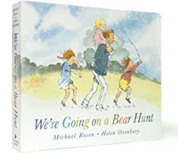  We’re going on a Bear hunt – Michael Rosen  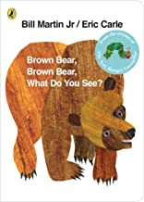  Brown Bear, Brown Bear – Eric Carle | 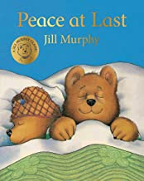  Peace at Last – Jill Murphy  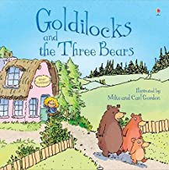  Goldilocks and the 3 bears |  | 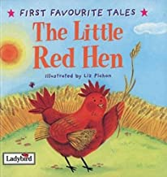  The Little Red Hen  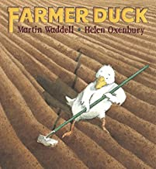  Farmer Duck – Martin Waddell | 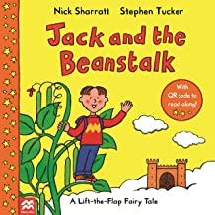  Jack and the Beanstalk  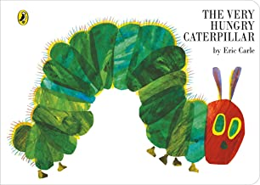  The Very Hungry Caterpillar – Eric Carle |  | 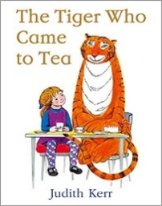  The Tiger who came to tea – Judith Kerr  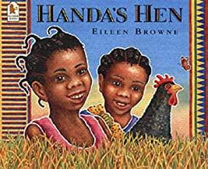  Handa’s Hen – Eileen Brown | 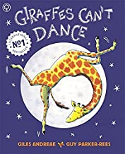  Giraffe’s Can’t Dance – Giles Andreae  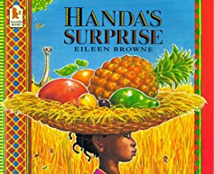  Handa’s Surprise – Eileen Brown
 | Additional Texts to compare: Jill Murphy  Whatever Next  The Large Family books |  |  | Additional Texts to compare: Traditional tales  The very busy spider – Eric Carle  The Tiny Seed – Eric Carle  The bad tempered ladybird – Eric Carle |  |  | Additional Texts to preload for Year 1:  Now Now Bernard – David McKee  The Day the Crayons Quit – Oliver Jeffers
 | Non – Fiction  Bears  Sleep, Bear!  All about bears |  | Poetry  The Little Brown Bear | Non - Fiction  Lifecycles  Farm animals |  | Poetry  Fairytale poems – Clare Bevan | Non – Fiction  Habitats  African animals |  | Poetry  Rumble in the Jungle  Commotion in the Ocean

Year Group | Autumn Term 1st |  | Autumn Term 2nd |  | Spring Term 1st
Y1  Autumn  Spring 1  Priority in year 1 is to secure the mechanics of reading. | Exposure to high quality texts with expansive vocabulary (bridging the gap from Foundation to Class Read in KS1)  Focus on Jez Alborough books -  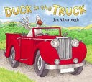  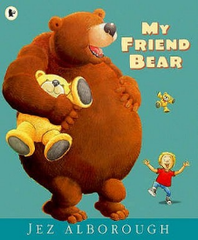  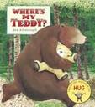  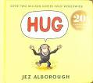 |  | Exposure to high quality texts with expansive vocabulary (bridging the gap from Foundation to Class Read in KS1)  Focus on traditional tales with alternate versions -  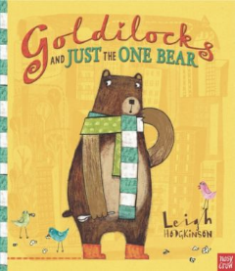  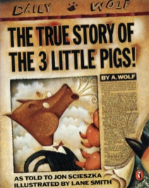  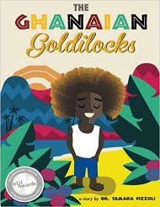  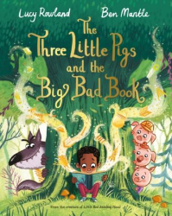 |  | 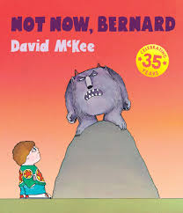  Not Now, Bernard - David McKee (Resistant Book)  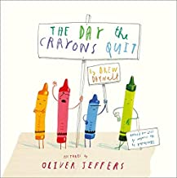  The day the Crayons quit. - Oliver Jeffers (Complexity of the narrator)
 | Additional Texts to compare:  Traditional Nursery Rhymes |  | Additional Texts to compare:  Goldilocks and the Three Bears - Traditional tale  Goldilocks and Just the One Bear – Alternate version |  | Additional Texts to compare: Theme of expressing feelings  Ravi’s Roar – Tom Percival  Eat your peas – Nick Sharratt
 | Non – Fiction  Autumn  Harvest  How to care for a Guineapig. | Poetry  Pi Corbet – Monster Alphabet | Non - Fiction  Bears | Poetry  Poems aloud – an anthology (focus on performing) | Non – Fiction  Frogs | Poetry  The Frog -  (Archaic Text)

Year Group | Spring Term 2nd |  | Summer Term 1st |  | Summer Term 2nd
Y1  Spring 2  Summer | 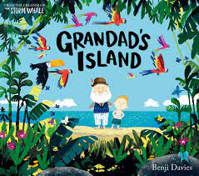  Grandad’s Island (Complexity of plot/symbol)  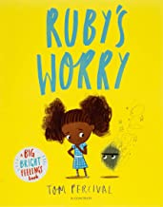  Ruby’s Worry – Tom Percival |  | 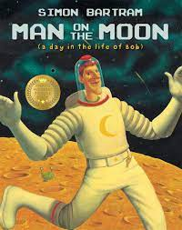  Man on the Moon – Simon Bartum  (Complexity of plot)  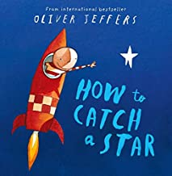  How to catch a star – Oliver Jeffers |  | 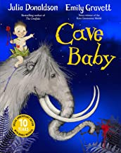  Cave Baby – Julia Donaldson  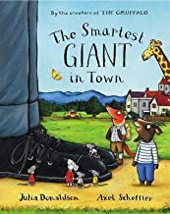  The Smartest Giant in Town – Julia Donaldson
 | Additional Texts to compare: Theme of worries  Peace at Last – Jill Murphy  I want my hat back – Jon Klassen |  | Additional Texts to compare: Theme of space  The darkest dark – Chris Hadfield  Mae among the stars – Roda Ahmed |  | Additional Texts to compare: Theme of key author  The Gruffalo – Julia Donaldson  Charlie Cook’s favourite Book – Julia Donaldson
 | Non – Fiction  Plant texts | Poetry  Paul Cookson – Truth About Teachers | Non - Fiction  Little Leaders – Bold Women in Black History (Mae Jemison) | Poetry  Poems about space | Non – Fiction  Ways into science: materials – Franklin Watts 2007 by Peter Riley. | Poetry  Poems aloud – an anthology Julia Donaldson

Year Group | Autumn Term 1st |  | Autumn Term 2nd |  | Spring Term 1st
Y2  Autumn  Spring 1 | 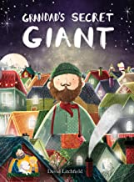  Grandad’s Secret Giant – David Litchfield  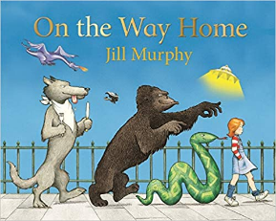  On the Way Home – Jill Murphy |  | 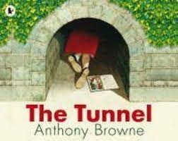  The Tunnel – Anthony Browne  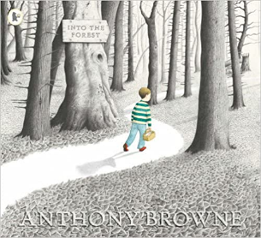  Into the Forest – Anthony Browne |  | 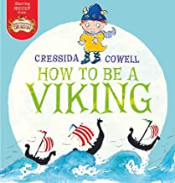  How to be a Viking – Cressida Cowell  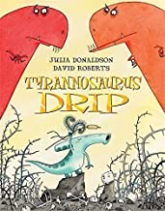  Tyrannosaurus Drip – Julia Donaldson
 | Other books for bridging themes/ knowledge: Mythical creatures  Billy and the Beast – Nadia Shireen  Beegu – Alexis Deacon |  | Other books for bridging themes/ knowledge: Same author, focus on feelings  Gorilla – Anthony Browne  Zoo – Anthony Browne |  | Other books for bridging themes/ knowledge: historical  How to wash a woolly mammoth – Michelle Robinson  Dragon Stew
 | Non – Fiction  Spiders – Usborne Beginners |  | Non – Fiction  Info text about Samuel Pepys | Poetry  Roar poem about dinosaurs – pre-load Tyrannosaurus Drip. | Non-fiction  Text about Vikings

Year Group | Spring Term 2nd |  | Summer Term 1st |  | Summer Term 2nd
Y2  Spring 2  Summer | 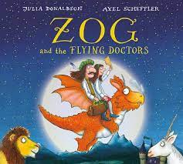  ZOG and the Flying Doctors – Julia Donaldson  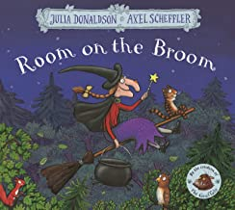  Room on the Broom – Julia Donaldson |  | 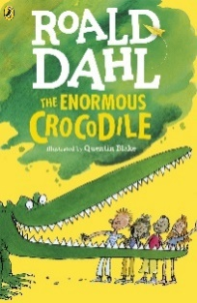  The enormous crocodile – Roald Dahl |  | 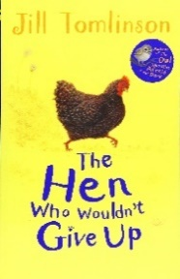  The hen who wouldn’t give up – Jill Tomlinson.
 | Other books for bridging themes: Helping others, friendship  Izzy Gizmo – Pip Jones  Snail and the Whale – Julia Donaldson |  | Other books for bridging themes: Diversity  Julian is a mermaid – Jessica Love  Elmer and Rose – David McKee |  | Other books for bridging themes: Overcoming problems  The Proudest Blue – Ibtihaj Muhammad  Good night owl – Pat Hutchins
 | Poetry  Julia Donaldson – Poems to perform. |  | Non – Fiction  Mary Seacole  Florence Nightingale  ^ Link to History |  |  | Poetry  Pie Corbett – The monster from outer space.

Year Group | Autumn Term |  |  | Spring Term |  |  | Summer Term
Y3 | The Tear Thief (2 weeks) - Planning from HCAT shared drive.  The Great Chocoplot |  |  | 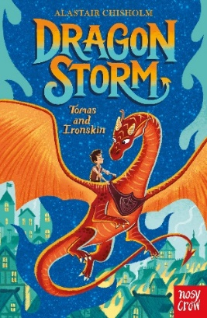  Dragon storm – Alastair Chisholm (610L) |  |  | 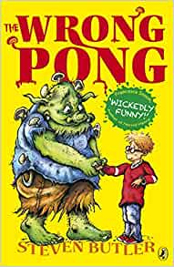  Wrong pong – Steven Butler
 | Other books for bridging themes :  Charlie and the Chocolate Factory -Roald Dahl. |  |  | Other books for bridging themes:  Dragon storm sequels: other books about dragons |  |  | Other books for bridging themes: Adapting to change/Books in a series  The Wrong Pong Sequels
 | Non – Fiction  Stone age to iron age | Picture book  The Lost Happy Endings | Poetry  Stone-Age poem | Non – Fiction  Plant | Picture book  Roald Dahl – Dirty Beasts | Poetry/ playscript  Little Red Ridding Hood  Linked poem from songs and verse by Roald Dahl | Non – Fiction  Eqyptians - Link to history | Picture book  Eqyptian cinderrella | Poetry Play script  Jabberwocky – Lewis Carroll  Alice in wonderland

Year Group | Autumn Term |  |  | Spring Term |  |  | Summer Term
Y4 | 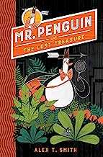  Mr Penguin and the Lost Treasure – Alex T Smith |  |  | 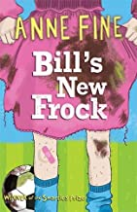  Bill’s New Frock - Anne Fine  (690L) |  |  | 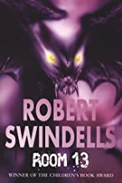  Room 13 – Robert Swindells  (690L)
 | Other books for bridging themes: Adventure, fantasy  Mr Penguin and the catastophic cruise  Mr Penguin and the Fortress of Secrets |  |  | Other books for bridging themes: Gender stereotypes and modern attitudes  Interstellar Cinderella – Deborah Underwood  The Boy in The Dress – David Walliams |  |  | Other books for bridging themes: Horror  Skellig- David Almond 490L  The Whitby Witches – Robin Jarvis  The Graveyard Book – Neil Gaiman
 | Non – Fiction  Everything Romans in Britain - National Geographic Kids  Roman Army - Ruth Brocklehurst  Roman Soldiers Handbook - Lesley Sim/Ian McNee  Roman News - Andrew Langley | Picture book  Professional Crocodile - Giovanna Zoboli | Poetry/ play script  The Raven - Edgar Allen Poem  Beowulf – Epic Poem | Non - Fiction  Earth Shattering events - Sophie Williams  Volcanos and Earthquakes DK eyewitness | Picture book  The Proudest Blue  The Invisible - Tom Percival | Poetry/ play script  Firework Night – Enid Blyton  The Magic Box – Kit Wright | Non – Fiction  Anglo Saxon boy - Tony Bradman  Men, women and children in Anglo Saxon times  History Detectives Investigates The Anglo Saxons | Picture book  If I were Primeminister - Trygve Skaug | Poetry  A kid in my class - Rachel Rooney & Chris Riddell

Year Group | Autumn Term |  |  | Spring Term |  |  | Summer Term
Y5 | 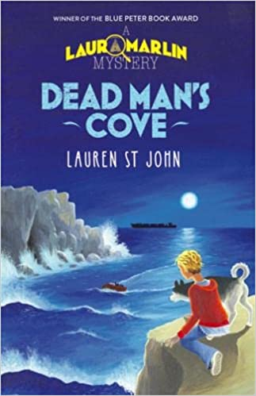  Dead man’s cove – Lauren St John |  |  | 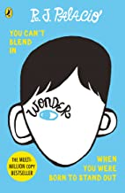  Wonder – R.J Palacio  (790L) |  |  | 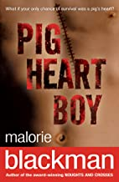  Pig Heart Boy – Malorie Blackman  (600L)
 | Other books for bridging themes: Geography link |  |  | Other books for bridging themes: Overcoming adversity  Voices in the Park |  |  | Other books for bridging themes: Persecution  A question of courage – Marjorie Drake  Arrival – Shaun Tan
 | Non – Fiction  The Ordnance Survey Guide to Smuggler’s Britain. | Picture book  The Secret of Black Rock. | Poetry/play script  The Highwayman – Alfred Noyles | Non – Fiction  Plastic Sucks – Dougie Pointer | Picture book  The Vanishing  Rainforest | Poetry/playscript  Letter to someone living fifty years from now – Matthew Olsmann | Non - Fiction  Malala – My Story of Standing Up for Girl’s Rights. (section). | Picture book  Malala’s magic pencil. | Poetry/playscript  PLAYSCRIPT

Year Group | Autumn – War |  |  | Spring – Adventure and Mystery |  |  | Summer – Female Lead
Y6 | 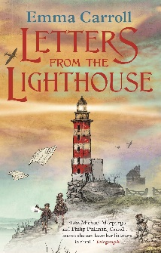  Letters from the Lighthouse – Emma Carroll (700) |  |  | 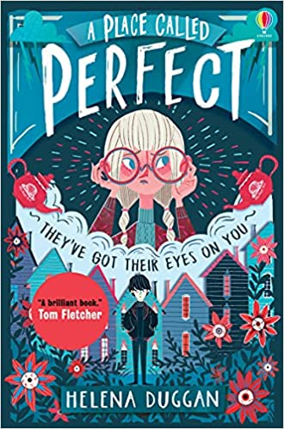  A Place Called Perfect - Helena Duggan (690) |  |  | 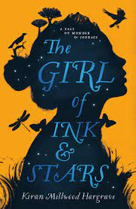  The Girl of Ink and Stars – Kiran Millwood Hargrave (710)
 | Other books for bridging themes:  When Hitler Stole Pink Rabbit – Judith Kerr  When the sky falls – Phil Earle |  |  | Other books for bridging themes:  Rooftoppers – Katherine Rundell |  |  | Other books for bridging themes:  Cogheart – Peter Bunzl  The house with chicken legs – Sophie Anderson
 | Non – Fiction  Anne Frank’s Diary- Extracts (link to writing)  Variety of extracts (Non-fiction Fridays) | Picture book  The day war came – Nicola Davies | Poem  Flanders Field – John McCrae | Non – Fiction  Variety of extracts (Non-fiction Fridays) | Play script  Alice in Wonderland – Lewis Caroll (Link to writing) | Poem  The Different Path – Mark Bird | Non – Fiction  Evolution and Inheritance – link to science unit.  Variety of extracts (Non-fiction Fridays) | Picture book/play script extracts  TBC | Poetry  The Jabberwocky – nonsense poem by Lewis Caroll (compare with Spring 2 play script – look at Caroll as an author)

