Personal, Social and Emotional Development  During our daily circles, we will listen to each other’s thoughts and ideas. We will also talk about our feelings and how they can affect others.  The school’s Jigsaw theme is ‘Changing Me’. This will help us to understand that everyone is special and unique. We will talk about what we are good at, and about any worries we might have about moving into a new class. |  | Communication, Language and Literacy  This half term the focus in Foundation Stage is on poetry and rhyme. We will continue to share and enjoy stories from other cultures.  We are very excited to be visiting Densholme Farm in June and following the visit we will be writing a recount in order to share our experience.  During our daily Read Write Inc. sessions we will continue to develop our phonic knowledge in order to read decodable and non-decodable words, this will help us to become more confident readers.  Through our daily interactions we will continue to develop our communication skills, we will be re-telling our favourite stories and making up our own. We will also enjoy telling others about our recent events and experiences. |  | Understanding the World  In this half term we will be focusing on sequencing events using basic chronology, recognising that things happened before we were born. We will also enjoy finding out about children in other parts of the world, and how their lives differ to ours.  We will continue to look at seasonal change, as the season moves into Summer, we will enjoy spending lots of time outdoors, visiting the farm and Pearson Park. This will also help us to name lots of different animals and the parts of their bodies.  We will be learning about ‘Special places’, and what makes a place special? We will talk about what places are special to us and others in our community.  For I.T. we are going to use a mouse to move the cursor on the computer and practise our typing skills to write our name!
Mathematics  This half term we are going to be working with numbers to 20. We will be doubling numbers and identifying if a number is odd or even. We will be sharing and grouping objects using different criteria.  We will continue to develop our knowledge of spatial reasoning, by being able to visualise and build using 2D and 3D shapes. |  | Our key texts for learning will be  ‘Giraffes Can’t Dance’ and ‘Handa’s Surprise’ |  | Expressive Arts and Design  In this half term we are focusing on sculpture and will be making animals using clay. We will continue to develop our ability to select appropriate materials and fix them together whilst making our Father's Day cards.  As part of our work about ‘Handa’s Surprise’ we will use some of the fruit in the story to make our own fruit salad! We will also continue to develop our colouring mixing skills, by mixing paints together to make hot colours.
 |  | 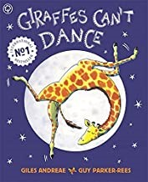 | 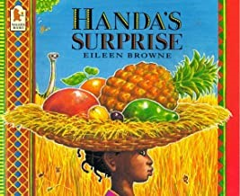
Physical Development

Our P.E. day is on a Thursday, we need to have our P.E. kits at school as it is important we get changed into them independently in preparation for year 1. This half term our focus is on ‘co-operative problem solving’.

