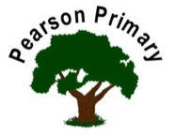
Personal, Social and Emotional Development  Through our daily circles, we will listen to each other’s thoughts and ideas. We will also talk about our feelings and how they can affect others.  The school’s Jigsaw theme is ‘Being me in my world’. This will help us to identify how we are similar and different from our friends, and understand that everyone is special and unique. |  | Communication, Language and Literacy  This half term the focus in Foundation Stage is on stories from familiar settings. We will also share and enjoy stories from other cultures.  During our daily Read Write Inc. sessions we will start to develop our phonic knowledge by learning some of the sounds that letters make.  Through our daily interactions we will develop our communication skills, we will enjoy telling each other about our recent events and experiences. |  | Understanding the World  In this half term we will start to look closely at changes in our environment as the season changes and identify different creatures we might find. We will also be learning ‘all about me’ and talking about who is in our family.  In R.E. we will enjoy taking part in our Harvest Festival, and think about what makes people special.
Mathematics  During this half term we are going to be matching and sorting lots of different objects. We will also be comparing amounts, finding out which set has more or fewer. We will enjoy exploring pattern by looking at patterns in our environment and making our own using Autumn objects we find on our ‘Autumn walk’. |  | Our key texts for learning will be  ‘Brown Bear…’ and ‘We’re Going on a Bear Hunt’ |  | Expressive Arts and Design  This half term we will sing some new and familiar songs, and learn lots of new nursery rhymes.  We will be exploring different materials, techniques and textures, focusing on joining materials using glue and tape. We will also start to develop our drawing skills, as we draw ourselves and our families.  We will enjoy creating simple representations of events, people and objects through art, music and role paly.
 |  | 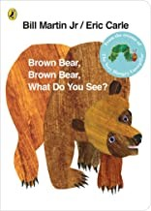 | 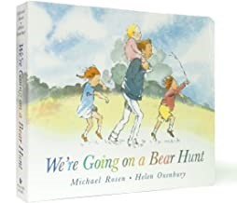
Physical Development

Our theme for this half term is ‘Manipulation and Coordination’. We will also be learning to follow instructions throughout the day, and during our weekly P.E. lessons.

We will be developing our gross motor skills through digging and sweeping the leaves in the garden. We will also be improving our fine motor control with malleable materials so we can develop our pencil grip and handwriting.

