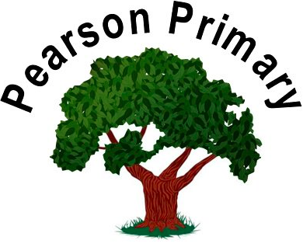

Pearson Primary School
Curriculum Policy

Updated: September 2023

Review Date: September 2024
Our Mission Statement
Pearson Primary School is a community that nurtures and supports every child; that values everyone’s unique worth and contribution; that empowers every member to achieve their fullest potential; that opens up a world of opportunities.
It is a place of safety where firm boundaries guide and support: where high expectations lead to lifelong learning; where care and respect build self-esteem and self-belief.
It is a gateway to limitless possibilities; to soaring aspirations; to brighter futures.
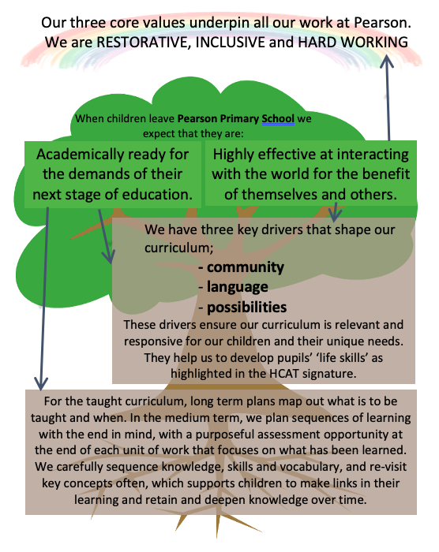
Curriculum Design

We plan from the National Curriculum to ensure breadth and balance. The five pillars of the HCAT Signature (Trust level – appendix 1) and the Pearson Key Drivers (school level – Appendix 2) shape both the planned content and the delivery.

We have identified and prioritised the content that our children need to learn in each curriculum subject, and we have developed progression maps for skills, knowledge and vocabulary in each National Curriculum subject and for specific Areas of Learning in EYFS, to support decisions about what is taught and when. Throughout school, subjects are carefully mapped out to ensure that sequences are given suitable time to strengthen and deepen the children’s knowledge and understanding.
Coherence is key; long-term plans ensure that main concepts are revisited often, and that links between learning are explicitly made, allowing children to have opportunity to both recall and recap their learning.
EYFS plan carefully to address identified gaps in knowledge and skills for children on entry to school, and effectively pre-load children to ensure they can access the Year 1 curriculum successfully.

When planning a sequence of learning we:

- plan with the end in mind - carefully choosing appropriate opportunities for children to demonstrate what they have learned. Knowing the minimum that we expect children to retain in terms of knowledge and skills for the sequence of learning.

- identify the component parts of final composites - specifically the knowledge, skills and vocabulary that children need to be successful. We then craft a sequence of learning that allows children to root ‘new’ knowledge in their ‘existing’ knowledge successfully. Skill development is prioritised when sufficient 'now knowledge' required is secure.

- use progression tools for all subjects to make sure that our pitch and expectations are appropriately high, and that knowledge, skills and vocabulary build effectively across year groups. This is used as a baseline when assessing the children’s knowledge and skills at the end of the unit.

- plan opportunities to develop children as members of a community, as learners of language and as explorers of possibilities, where appropriate.

Our curriculum is delivered using a variety of approaches and resources depending on the nature of the subject being taught and the needs of the children (for more details please refer to the separate subject policies and the Learning, Teaching and Assessment policy). Subject leaders make links from their subjects to the relevant Areas of Learning in EYFS and planning begins from the start in Nursery.

Separate curriculum statements and policies:

- Reading | - Writing | - Art
- Maths | - Science | - Languages (Latin)
- PE | - Music | - PSCHE and SRE
- History | - Geography | - Computing
- RE | - Design Technology

Meeting the needs of all learners
Some children have an Educational Health Care Plan (EHCP) that may outline that a bespoke curriculum is required for some subjects. Careful adaptations are made so that children can access the school’s curriculum where possible and appropriate. If a bespoke curriculum is required, the SENDCo and the SEND teacher will prepare bespoke sequences of learning or support the teacher to make adjustments to their plans.

Delivering the Curriculum

The curriculum is the totality of the children’s learning experiences, alongside the subject specific curriculum. We plan an enrichment curriculum to promote learning and personal growth and development. Examples of this at Pearson would be through: fulfilling leadership roles in school; attending extra-curricular activities; leading and attending assemblies; and working in family groups.

The curriculum also includes the ‘hidden curriculum’, or what the children learn from the way that they are treated and how they treat others at school. At Pearson Primary School, we aim to teach all children British values and how to be positive, responsible people, who can work and co-operate with others so that they are able to achieve their true potential. This is developed through our three core values: restorative, inclusive and hardworking (Appendix 3).

Monitoring the Implementation and Impact of the Taught Curriculum

Using Assessment
The school’s core subject curriculum has clear Key Performance Indicators that have been designed to ensure pupils at the end of each year learn the key knowledge and skills that underpin all future learning and allows them to make exceptional progress.

In the foundation subjects, we have assessment opportunities at the end of each sequence of learning. These are used to identify any areas of knowledge/skills that children have not retained. Teachers use this information to either reteach the concept or inform the subsequent teacher of this learning need. This information is also given to the subject leaders so they can ensure the knowledge/skills are caught up on. We also use the National Curriculum statements to benchmark at the end of each key stage in Foundation Subjects.

Phase meetings are scheduled to support teachers to analyse assessment information, adapt the sequences of learning for the next year and to help them write and/or adapt the medium-term plans for the next unit.

Monitoring Sequences
Long-term planning is reviewed at least annually. Medium term planning is monitored half-termly by subject leaders. Immediate feedback is given to teachers prior to the sequence of learning starting; adaptations to sequences of learning are made as required.

Subject Leaders monitor their subjects in a number of ways. Mid-sequence book looks take place to ensure learning is on-track. Feedback and adaptation to the remainder of the sequence takes place, if needed. At the end of a sequence of leaning, leaders carry out book looks, pupil talk, and discuss pupil outcomes with teachers. This information is used to make improvements to the medium-term plans before their delivery in the next academic year.

Senior Leaders complete a ‘Deep Dive’ in every subject over the course of two years, supported by Trust or other external partners by request. Termly supervision with the Curriculum Lead is in place to support subject leaders and to ensure consistently high standards and consistency in approach.

Appendix 1

Appendix 2
Our key drivers

We have identified three key drivers that shape our curriculum; ensuring that it is relevant and responsive to our children’s unique context and needs. These are;
- community
- language
- possibilities
When defining the content of our curriculum and establishing the sequence of learning, our key drivers shape both the content and the delivery.

Community

‘Our differences are our strength as a species and as a world community’
Nelson Mandela

- As members of a community we will:
Work restoratively
Strengthen our cultural identity and our acceptance and understanding of difference
Develop a strong sense of pride and belonging
Act compassionately and contribute beyond us and our school

Language

‘Language shapes the way we think, and determines what we can think about’
Benjamin Lee Whorf

- As learners of language we will:
Share stories and learning from text in all areas of the curriculum
Develop a wider vocabulary and apply words in different contexts
Communicate effectively, though the spoken and written word, and through technology

Possibilities

‘When you focus on possibilities you have more opportunities’
Zig Ziglar

- As explorers of possibilities we will:
Extend our lived experiences and broaden our horizons
Develop courage to embrace unfamiliar experiences
Seek to identify possibilities from our lived experiences
Raise aspirations and prepare for our futures and career opportunities

Appendix 3
Our Core Values
Pearson Core Values

At Pearson we value enjoyment and positivity.
We are RESTORATIVE, INCLUSIVE and
we are HARD WORKING.

To be RESTORATIVE means to build respectful relationships and to repair harm when harm is done. This requires respect for myself and for others, honesty and the strength to take responsibility for my actions.

To be INCLUSIVE means to value and celebrate individuality and difference. This requires curiosity, empathy and care. We need to develop the courage and commitment to making a positive difference.

To be HARD WORKING means to try our hardest and to be resilient. This requires increasing independence, consistency and a determination to be successful.

