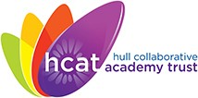
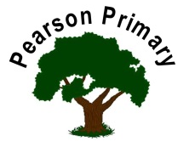
 | 2023-2024
 | Autumn | Spring | Summer
EYFS
Year 1 | Drawing – Urban Landscape  Artists – LS Lowry, David Hockney, Eric Ravilious | Painting – Colours  Artists – Murakami, Monet, Paul Klee | Mixed Media – Nature  Artists – Andy Goldworth, Georgia O’Keefe, James Brunt
Year 2 | Drawing – Self-portraits  Artists – Van Gough, Frida Kahlo, Picasso | Printing / Collage  Artists – Karen Lederer, Henri Matisse | Sculpture – Ceramics  Artists – Clarice Cliff, Hornsea Pottery
Year 3 | Painting / Drawing – Landscapes  Artists – Tracey Savage, John Constable, Henry Dawson, David Hockney | Mixed Media – Eyes  Artists – Adrian Gottlieb, Jose Vergara | Interior Design – Wallpapers  Artist – William Morris
Year 4 | Painting / Drawing – Maritime Art  Artists – John Ward, Jason Scarpace | Mixed Media – Wildflowers  Artists – Joris Hoafnagel, Charles Reid, Yayoi Kusama | Drawing – Graffiti  Artists – Banksy, Keith Haring
Year 5 | Painting / Drawing – French Impressionism  Artists – Monet, Manet, Renoir, Degas | Portraits – Photography  Artists – Vivian Maier, Hannah Hoch | Mixed Media – Birds  Artists – John James Audubon, Mike Godwin
Year 6 | Painting / Drawing – Pop Art  Artists – Andy Warhol, Roy LIchenstein | Drawing – Still Life  Artists – Cezanne, Fede Galizia | Drawing – Architecture  Artist – Filippo Brunelleschi

