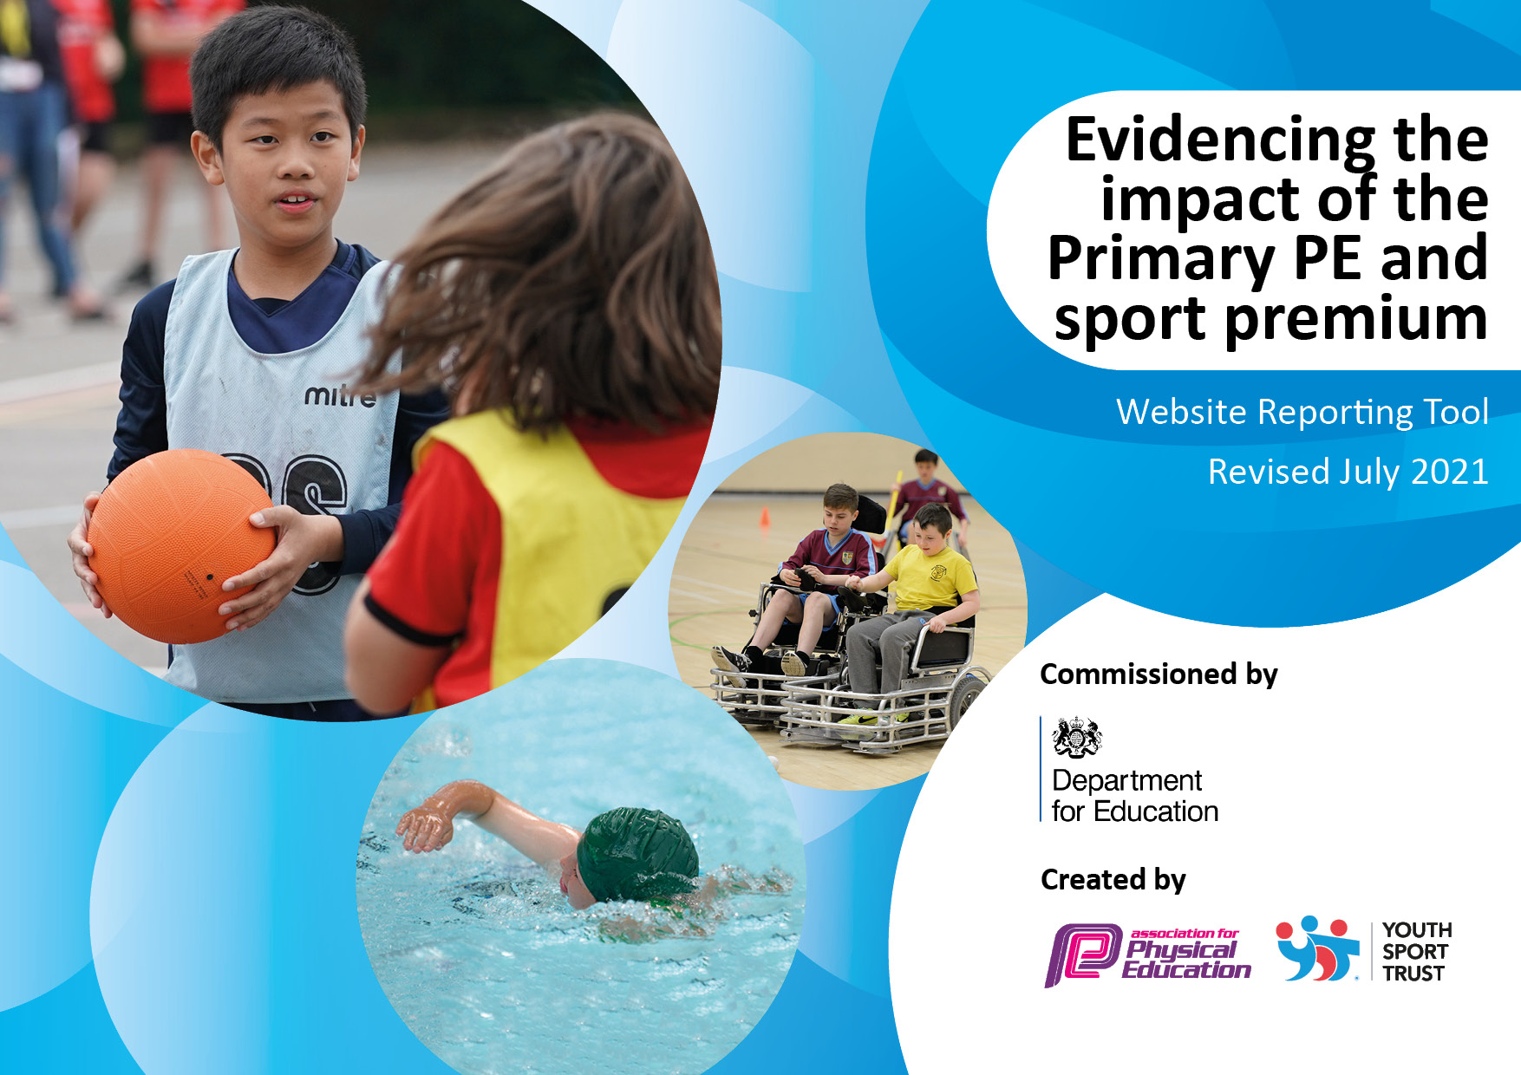
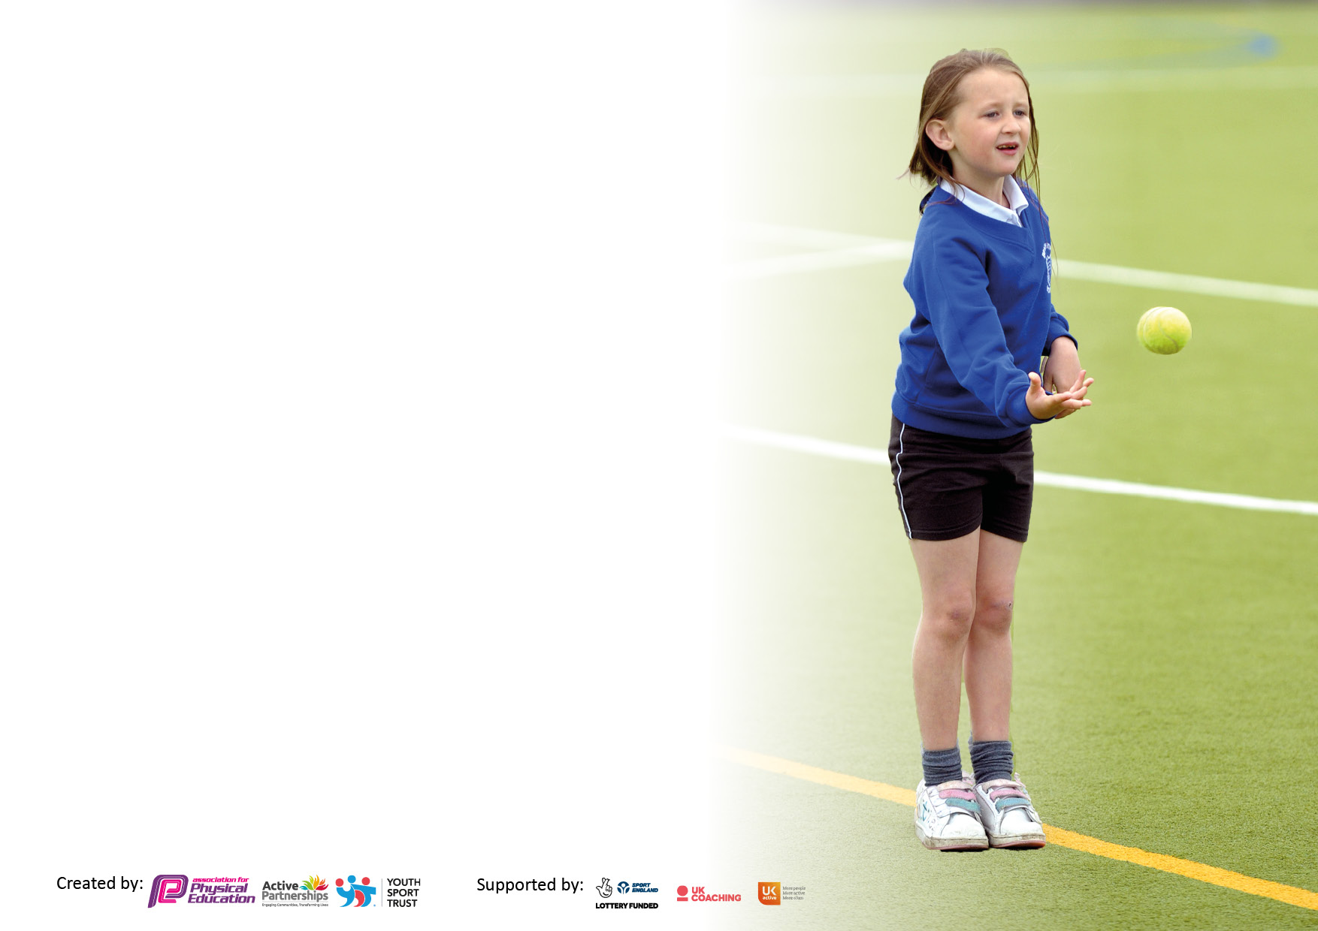
It is important that your grant is used effectively and based on school need. The Education Inspection Framework makes clear there will be a focus on ‘whether leaders and those responsible for governors all understand their respective roles and perform these in a way that enhances the effectiveness of the school’.

Under the Quality of Education Ofsted inspectors consider:
Intent - Curriculum design, coverage and appropriateness
Implementation - Curriculum delivery, Teaching (pedagogy) and Assessment
Impact - Attainment and progress

To assist schools with common transferable language this template has been developed to utilise the same three headings which should make your plans easily transferable between working documents.

Schools must use the funding to make additional and sustainable improvements to the quality of Physical Education, School Sport and Physical Activity (PESSPA) they offer. This means that you should use the Primary PE and sport premium to:

- Develop or add to the PESSPA activities that your school already offer
- Build capacity and capability within the school to ensure that improvements made now will benefit pupils joining the school in future years
- The Primary PE and sport premium should not be used to fund capital spend projects; the school’s budget should fund these.

Pleasevisitgov.ukfortherevisedDfEguidanceincludingthe5keyindicatorsacrosswhichschoolsshoulddemonstrate animprovement.Thisdocumentwillhelpyoutoreviewyourprovisionandtoreportyourspend.DfEencouragesschools to use this template as an effective way of meeting the reporting requirements of the Primary PE and sport premium.

We recommend you start by reflecting on the impact of current provision and reviewing the previous spend.

Schools are required to publish details of how they spend this funding, including any under-spend from 2019/2020, as well as on the impact it has on pupils’ PE and sport participation and attainment. All funding must be spent by 31st July 2022.

We recommend regularly updating the table and publishing it on your website throughout the year. This evidences your ongoing self-evaluation of how you are using the funding to secure maximum, sustainable impact. Final copy must be posted on your website by the end of the academic year and no later than the 31st July 2021. To see an example of how to complete the table please click HERE.

Details with regard to funding
Please complete the table below.

Total amount carried over from 2019/20 | £1,260
Total amount allocated for 2020/21 | £17,680
How much (if any) do you intend to carry over from this total fund into 2021/22? | £1,360
Total amount allocated for 2021/22 | £17,680
Total amount of funding for 2021/22. To be spent and reported on by 31st July 2022. | £20,300
Swimming Data
Please report on your Swimming Data below.

Meeting national curriculum requirements for swimming and water safety.  N.B. Complete this section to your best ability. For example you might have practised safe self-rescue techniques on dry land which you can then transfer to the pool when school swimming restarts.  Due to exceptional circumstances priority should be given to ensuring that pupils can perform safe self rescue even if they do not fully meet the first two requirements of the NC programme of study | The children in this cohort completed their initial swimming lessons in Year 4 and then didn’t have opportunity to take part in further lessons in Year 5 due to the disruption caused by the COVID-19 pandemic. *
What percentage of your current Year 6 cohort swim competently, confidently and proficiently over a distance of at least 25 metres?  N.B. Even though your pupils may swim in another year please report on their attainment on leaving primary school at the end of the summer term 2020.  Please see note above | 36%
What percentage of your current Year 6 cohort use a range of strokes effectively [for example, front crawl, backstroke and breaststroke]?  Please see note above | 28%
What percentage of your current Year 6 cohort perform safe self-rescue in different water-based situations? | *The specific knowledge for ‘self rescue’ is not taught as part of the Year 4 swimming curriculum.
Schools can choose to use the Primary PE and sport premium to provide additional provision for swimming but this must be for activity over and above the national curriculum requirements. Have you used it in this way? | Yes

Action Plan and Budget Tracking
Capture your intended annual spend against the 5 key indicators. Clarify the success criteria and evidence of impact that you intend to measure to evaluate for pupils today and for the future.

Academic Year: 2020/21 | Total fund allocated: £20,300 | Date Updated: 24.11.2021
Key indicator 1: The engagement of all pupils in regular physical activity – Chief Medical Officers guidelines recommend that primary school pupils undertake at least 30 minutes of physical activity a day in school |  |  |  | Percentage of total allocation:
 |  |  |  | 32.5%
Intent | Implementation |  | Impact
Your school focus should be clear what you want the pupils to know and be able to do and about  what they need to learn and to  consolidate through practice: | Make sure your actions to achieve are linked to your intentions: | Funding allocated: | Evidence of impact: what do pupils now know and what can they now do? What has changed?: | Sustainability and suggested next steps:
- All pupils to increase the amount of time that they are active throughout the day (aim for 30 minutes per day) with the support of Pupil Sports Leaders.  - Encourage pupils to become more active outside of school.  - Involve parents and families in becoming more active with their children. | - All pupils to access 90 minutes of quality PE every week.  - All children encouraged to attend a club – either before school, at lunch or after-school.  - All Year 4/5 pupils to receive intensive swimming lessons.  - Year 4/5/6 non-swimmers to attend booster lessons.  - All pupils to participate in an intra-competition every term.  - Enhance activity at break and lunch times.  - Clubs and activities organised by the PE lead and supported by Pupil Sports Leaders.  - Use of external visitors to celebrate and advocate being active.  - Introduce and train staff on the use of BBC Supermovers.  - Families to receive pack of information on active learning, healthy eating websites and local sports clubs the children could join. | Staff to run clubs:  Cost of Y4/5 swimming:  £3000  Cost of booster swimming:  £2000  Staff training costs:  £1500  Printing costs of resources for families:  £100
Key indicator 2: The profile of PESSPA being raised across the school as a tool for whole school improvement |  |  |  | Percentage of total allocation:
 |  |  |  | 4%
Intent | Implementation |  | Impact
Your school focus should be clear what you want the pupils to know and be able to do and about  what they need to learn and to  consolidate through practice: | Make sure your actions to achieve are linked to your intentions: | Funding allocated: | Evidence of impact: what do pupils now know and what can they now do? What has changed?: | Sustainability and suggested next steps:
- To promote healthy lifestyle choices.  - To inspire achievement in sport at any level.  - To ensure all children are proficient in the fundamentals of sport.  - To provide opportunities for children to develop skills so they can play a variety of sports.  - To provide the children with self-esteem, confidence, and self-belief.  - Sports engagement to lead to improved attendance, behaviour and academic outcomes. | - PE objectives link to school learning behaviours and core values.  - Display values and expectations when participating in sport.  - Purchase new kits for the school teams.  - Report PE at school and in competitions regularly on Class Dojo and Twitter.  - Assemblies led by pupils celebrating achievements and major sporting events.  - Ensure Pupil Sports Leaders are clearly recognised.  - Display awards and trophies prominently.  - Develop a ‘Girls Active’ club at lunchtimes. | New kits:  £300  Training of Pupil Sports Leaders:  £300  Vests for Pupil Sports Leaders:  £200

Key indicator 3: Increased confidence, knowledge and skills of all staff in teaching PE and sport |  |  |  | Percentage of total allocation:
 |  |  |  | 10.6%
Intent | Implementation |  | Impact
Your school focus should be clear | Make sure your actions to | Funding | Evidence of impact: what do | Sustainability and suggested
what you want the pupils to know | achieve are linked to your | allocated: | pupils now know and what | next steps:
and be able to do and about | intentions: |  | can they now do? What has
what they need to learn and to |  |  | changed?:
consolidate through practice:
- Enhance the knowledge, confidence and skills of staff to ensure the quality of PE is consistently good, or higher, across the school. | - Mentoring programme for all staff.  - PE SLE to help improve confidence and expertise of staff.  - PE lead to be supported by SLT to ensure effective subject leadership and monitoring.  - Join Youth Sport Trust to be able to access their programmes (Girls Active). | Staff release time for mentoring:  £500  SLE cost for mentoring:  £1200  PE lead release time:  £250  Youth Sports Trust Membership:  £210
Key indicator 4: Broader experience of a range of sports and activities offered to all pupils |  |  |  | Percentage of total allocation:
 |  |  |  | 34.2%
Intent | Implementation |  | Impact
Your school focus should be clear | Make sure your actions to | Funding | Evidence of impact: what do | Sustainability and suggested
what you want the pupils to know | achieve are linked to your | allocated: | pupils now know and what | next steps:
and be able to do and about | intentions: |  | can they now do? What has
what they need to learn and to |  |  | changed?:
consolidate through practice:
- Pupils to understand what can be achieved, irrespective of disabilities, and to develop staff awareness and confidence in delivering PE to all pupils.  - Embed sports leadership in school, ensuring it is key in supporting and developing opportunities for pupils to be healthy, active and competitive.  - Target disadvantaged pupils by introducing children to a new sport or a wider range of sports through an extensive before and after-school club programme. | - Whole school sports inclusion day.  - Train and develop role of Pupil Sports Leaders.  - Leaders supported by lunchtime staff to deliver active lunchtimes – to include skipping, balances, badminton and gym equipment circuits.  - Clubs to take place before school, at lunchtimes and after-school. All clubs then supported by a termly inter-house competition to give those attending the chance to compete.  - Make links with local sporting clubs to access specialist clubs e.g. gymnastics.  - PE lead to update curriculum LTP to ensure coverage of a range of sports.  - All pupils to participate in 90 minutes of taught PE per week.  - More opportunities for children to access lesser-known sports. | Resources for sports inclusion day:  £2390  Training of Pupil Sports Leaders:  £300  Staffing costs of clubs:  £1500  PE lead release time:  £250  Transport costs to specialist clubs:  £1000  Hire costs of specialist venues:  £1500

Key indicator 5: Increased participation in competitive sport |  |  |  | Percentage of total allocation:
 |  |  |  | 18.7%
Intent | Implementation |  | Impact
Your school focus should be clear | Make sure your actions to | Funding | Evidence of impact: what do | Sustainability and suggested
what you want the pupils to know | achieve are linked to your | allocated: | pupils now know and what | next steps:
and be able to do and about | intentions: |  | can they now do? What has
what they need to learn and to |  |  | changed?:
consolidate through practice:
- To increase inter-house competitions to provide all pupils with competitive opportunities.  - Pupils to develop their sportsmanship, focusing on school games values (respect, resilience, responsibility, kindness, aspiration and courage) and our school core values (restorative, hardworking and inclusive).  - PE lead to develop the confidence of Pupil Sports Leaders and provide greater opportunities for students to lead, manage and officiate. | - Personal Best lunch time challenges for KS1 – intraschool competition. Pupil Sports Leaders trained to deliver.  - Before and after-school clubs relating to the competition calendar.  - Join HAPS to access inter-school competition and training.  - Taking pupils to appropriate events to allow them to thrive, such as a specialist SEN or a festival for inactive low confidence pupils.  - Organise a school Race for Life event to engage with families.  - Intraschool competition each term. | Staffing costs of clubs:  £1500  HAPS membership cost:  £1500  Transport costs to sports events:  £800

