Handwriting at Pearson – A Guide for Families

Letter Phrases

As soon as children start with us in EYFS we begin teaching letter formation using the Read, Write, Inc. phrases.
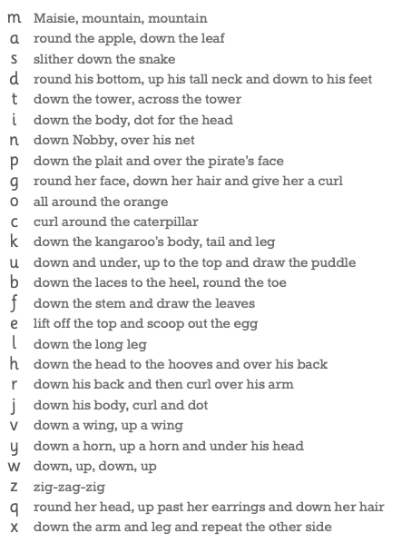

We teach the children the correct sitting position and tripod grip for writing.
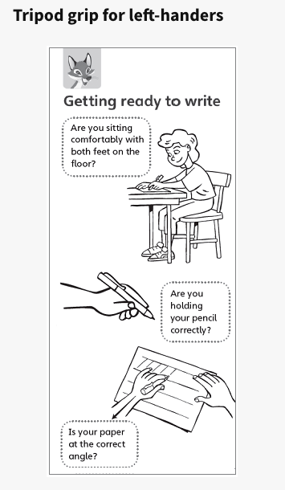 | 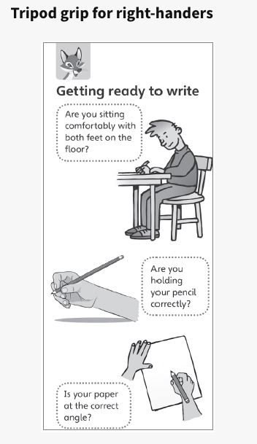
The Letter Families

We explicitly teach handwriting in letter families in year 1.
These are letters that are formed in similar ways.
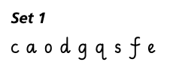 | 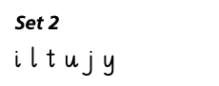
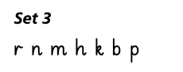 | 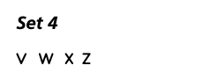
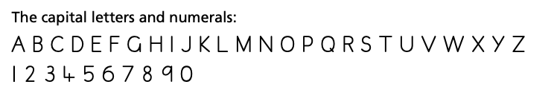

Joining Groups

The joining groups divide the letters accoridng to how they join to other groups. We encourage children to slant their letters at the beginning of year 2 anf then we begin teaching the joins later in year 2, when the children have secured their letter formation.

Thirteen letters with exit flicks plus s.
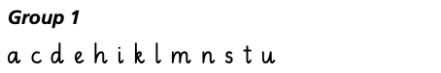
Nineteen letters which start at the top of the x-height.
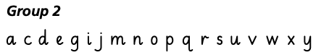
Six letters which start at the top of the ascender.
Five letters which finish at the top of the x-height.
Eight letters after which no join is made. Joins are not made to or from the letter z.
