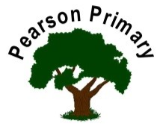
Writing  In this second half term the priority will be on narrative writing. We will innovate stories with new characters and creative problems. We will end the term with some poetry writing, just in time for World Poetry Week. We are looking forward to sharing some of this work with our school community. |  | Maths  This half term is all about fractions! We will be working with halfs, thirds, quarters and wholes and making sure that we understand what equivalence means. We will all have opportunity to reason and problem solve, applying our new learning this term. |  | Reading  This term we will continue to develop our love of books and reading. Our main focus will be: to read accurately, with good pace and prosody.  Our texts will be: Cliff-hanger and Horrid Henry  We will practise our fluency and expression, daily, during our Read Write Inc. sessions if we still need this.
Science  This half term we will continue to learn about pants, building on our learning from year 2. We will plan fair tests, learning to identify variables to ask a scientific question. |  | PSHCE  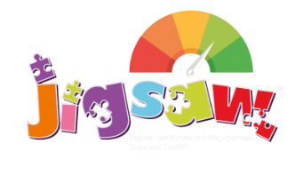  The school’s Jigsaw theme is Healthy Me. We will study healthy and safe choices in regard to food, drugs and fitness. We look at the meaning of self-respect and how to keep ourselves safe online. |  | Geography  We will be learning about types of land use and settlements. We will be developing our mapping skills through this work and  building on the smaller scale mapping skills that we learned in year 1.
Art  This half term we will be exploring the medium of painting. |  | RE  Our principal religion this half term is Christianity.  We will be learning about Easter.  The key question that we will explore is:  What is ‘good’ about Good Friday? |  | Music  We will be creating compositions in response to animation, using tuned instruments and sharing the music we create with each other.
PE  Our PE day is on Wednesday.  This half term we will be completing our annual work in dance and building on the skills that we learned in year 2. |  |  | Latin  This half-term, we will continue our Latin journey through the Maximum Classics scheme of work. Children will learn present tense verbs this term which will also strengthen their disciplinary knowledge of language learning.

