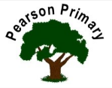
Writing  The second half of the Spring Term is all about developing our character and setting descriptions so that our narrative writing continues to improve. We will also be taking the opportunity to reinforce our learning about road safety through writing recounts. |  | Maths  This half term we will be working on fractions and moving on to Money and Geometry. We will be learning all about the properties of shapes, working with both 2-D and 3-D shapes, securing our knowledge about faces, edges, vertices and symmetry. | Reading  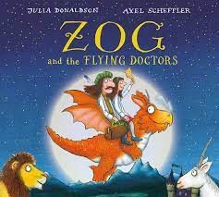  In ‘Class Read’ we will be continuing to read books by the author Julia Donaldson such as ‘Zog and the Flying Doctors’ and ‘Room on the Broom.’ Through these, we will look at the skills of inference, sequencing and retrieval. We will practise our fluency and expression, daily, during our Read Write Inc. sessions.
Science  This half term, we will begin a long unit on plants that will take us in to the Summer Term. We will learn about how seeds and bulbs grow into plants and develop our disciplinary knowledge of observing over time and making comparisons. |  | Geography  Our learning will focus on Hull and builds on the local area studies that we completed in year 1. We will focus on developing our mapping skills this half term and our understanding of similarities and differences through studying both the human and physical geography of Hull. | Music  Musical me: Singing and playing a song  Children learn to sing the song ‘Once a Man Fell in a Well’ and to play it using tuned percussion. Using letter notation to write a melody.
Art  This half term we will be exploring the medium of painting. |  | RE  Our principal religion this half term is Christianity.  We will be learning about Easter (Resurrection)  The key question that we will explore is:  How important is it to Christians that Jesus came back to life after his crucifixion? | PSHCE  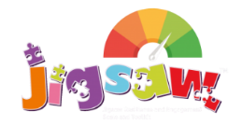  The school’s Jigsaw theme is Healthy Me. We will focus on motivation and relaxation. We will look at healthy eating and nutrition and consider healthier snacks that we can eat.
PE
Our PE day is on Monday.
This half term we will be completing our gymnastics unit of work and building on the skills we learned in year 1.

