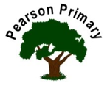 | 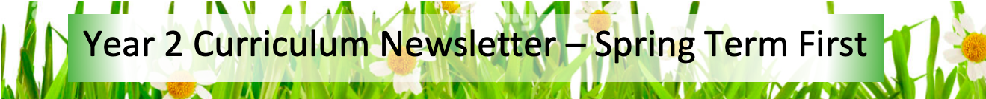
Writing  We have a very busy half term to start this Spring, writing narrative pieces, instructions, and some poetry, just in time for World Poetry Day. We will be focussing on acrostic poems and are expecting to have lots of fun writing creative pieces about some of the animals that we will be learning about in science. |  | Maths  This term we will be learning about multiplication and division. As always, we will continue to strengthen our number skills daily in our lessons. | Reading  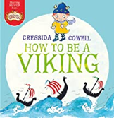  In ‘Class Read’ we will be reading 'How to be a Viking‘ by Cressida Cowell and ‘Tyrannosaurus Drip’ by Juila Donaldson. Through these, we will look at the skills of inference, sequencing and retrieval.  We will practise our fluency and expression, daily, during our Read Write Inc. sessions.
Science  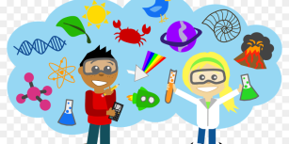  This half term, we will be learning about Living Things and their Habitats. We will continue to deepen our understanding about habitats, and we will focus on developing our pattern seeking skills. |  | History  We will be developing our understanding of the two key historical concepts of cause and consequence through our study of the Great Fire of London and the life of Samuel Pepys. | Computing  In Computing this half term, we will be developing our word processing skills.
Design Technology  The focus of Design Technology this half term is construction with a focus on vehicle design and production.  The children will measure and saw strip wood and dowel to create the base of a vehicle and axels, evaluating the success of their work. |  | RE  Our principal religion this half term is Islam.  Our linked religion is Christianity.  We will focus our studies on prayer at home.  The key question that we will explore is:  Does praying help a Muslim/Christian in their everyday life? | PSHCE  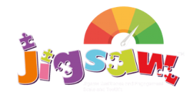  The school’s Jigsaw theme is Dreams and Goals this half term. We will be focussed on what perseverance means and how to work with others towards achievable goals, contributing to and sharing success.
PE
Our PE day is on Monday.
In Year 2, we will be learning how to keep fit and working on improving our fitness.

