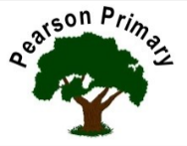
Writing  This half term we will continue to work on our narrative skills, retelling stories and innovating with our own ideas. We will also be writing poetry this half term, just in time for World Poetry Day! We will be sharing and enjoying a range of poems by Michael Rosen during the term. |  | Maths  This half term we are going to be focussing on developing our skills and knowledge in measurement. We will be learning about length and height, weight and volume. It’s a very practical and fun time in year 1! | Reading  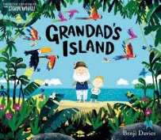  In ‘Class Read’ we will be reading 'Grandad’s Island’ by Benji Davis and ‘Ruby’s Worry’ by Tom Percival. Through these, we will look at the skills of inference, sequencing, and retrieval. We will continue to practise our reading fluency and expression, daily, during our Read Write Inc. sessions.
Science  This half term we will learn about plants, we will focus on improving our observations over time.  Building on our work on seasons in the Autumn Term, we will focus on the signs of Spring and compare this season to those previously studied. |  | PSHCE  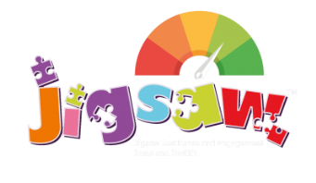  The school’s Jigsaw theme is Healthy Me. We will focus on being healthy and keeping safe. This work will support our understanding of safety in the home, including with medicines and safety on the road. | Geography  Building on from our learning about our local area in EYFS in in the Autumn Term of year 1, we will be comparing urban and rural areas this half term.
Art  This half term we will be exploring the medium of painting. |  | RE  Our principal religion this half term is Christianity.  We will be learning about Easter (Palm Sunday)  The key question that we will explore is:  Why was Jesus welcomed like a king or celebrity by the crowds on Palm Sunday? | Music  Musical vocabulary: “Under the sea”  Children journey into the unknown and explore under the sea through music, movement, chanting and the playing of tuned percussion instruments.
PE - Our PE day is on Monday.
This half term we will be continuing to develop our skills in dance. Building on the work that we did in EYFS.
Appropriate PE indoor kit is bare feet, dark shorts/leggings, and white T-shirt (no jogging bottoms, tights or jumpers). NO JEWELLERY please.

