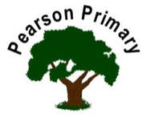 | 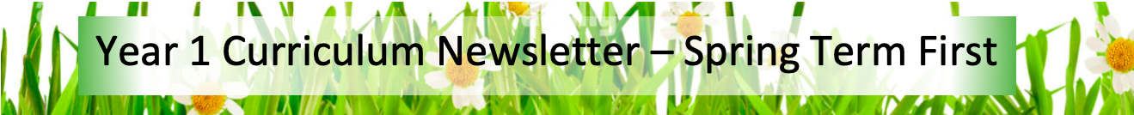
Writing  This half term we will be improving our narrative skills through work on setting descriptions. We will be reinforcing our learning in science and learning about non-chronological reports through our writing about the human body. |  | Maths  This half term we are going to focus on adding and subtracting numbers within 20 before we move on to understanding the place value of numbers within 50. Will also be practicing counting in 2’s and 5s throughout the whole of the Spring Term. | Reading  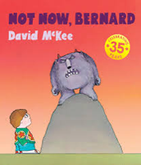  In ‘Class Read’ we will be reading 'Not Now Bernard’ by David McKee and ‘The Day the Crayons Quit’ by Oliver Jeffers. Through these, we will look at the skills of inference, sequencing and retrieval.  We will continue to practise our reading fluency and expression, daily, during our Read Write Inc. sessions.
Science  This half term we will continue to learn about animals, including humans, building on the work that we did in the Autumn Term. We will focus on grouping and classifying animals based on what they eat. |  | PSHCE  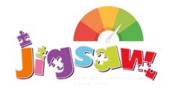  The school’s Jigsaw theme is Dreams and Goals this half term. We will be building on the work that we did in EYFS to explore more deeply what it means to be successful in overcoming obstacles and how to work well and celebrate our achievements. | History  We will be developing our understanding of the key historical concept of significance through our study of a local significant person. We will be learning about the life of Amy Johnson.
Design Technology  The focus of Design Technology this half term is construction with a focus on vehicle design and production.  Children will research, design and then make a 3D vehicle from card, with suitable, sturdy 3D joints and wheels that rotate. |  | RE  Our principal religion this half term is Christianity.  Our linked religion is Islam.  We will focus our studies on Jesus and Mohammed as a friend.  The key question that we will explore is:  Was it always easy for Jesus/Mohammad to show friendship? | Computing  In Computing this half term, we will be developing our word processing skills.
PE - Our PE day is on Monday.
This half term we will be working on our gymnastics skills.
Appropriate PE indoor kit is bare feet, dark shorts/leggings, and white T-shirt (no jogging bottoms, tights or jumpers). NO JEWELLERY please.

