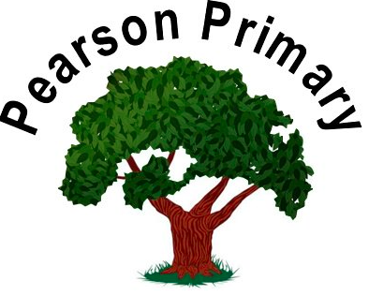
The Pearson Curriculum – A Guide for Families

Welcome to Pearson Primary School! This information is to support you to quickly understand the approach of the school, whether your child is joining us right from the start in Foundation Stage or at another time. We feel very strongly that our children have the best chance of success if we work in strong partnership with our families so we will regularly be in touch to share resources, training and reminders so that you can support your child confidently.

Our website has lots of information and helpful links to guide your child and yourself through our curriculum approach. The named lead for each area of the curriculum is on the subject page on the website to support you to ask for the right staff in school should you have any questions. Mr Lane and Mrs Neale have overall responsibility for the curriculum so there will always be someone available for support.

Our website can be found using the following link.
https://pearsonprimaryschool.co.uk/

Our Curriculum Aims

When children leave Pearson Primary School, we expect that they are academically ready for the demands of the next stage of their education and that they are highly effective at interacting with the world for the benefit of themselves and others.

Our Core Values
At Pearson we value enjoyment and positivity.
We are RESTORATIVE, INCLUSIVE and we are HARD WORKING.
To be RESTORATIVE means to build respectful relationships and to repair harm when harm is done. This requires respect for myself and for others, honesty and the strength to take responsibility for my actions.
To be INCLUSIVE means to value and celebrate individuality and difference. This requires curiosity, empathy and care. We need to develop the courage and commitment to making a positive difference.
To be HARD WORKING means to try our hardest and to be resilient. This requires increasing independence, consistency and a determination to be successful and means we have to learn to try our hardest and to be resilient.
Each half term we focus on one of our core values and they form the starting point for the planning of our enrichment curriculum. This means that children will be exploring elements of our core values in assemblies, class circles, PSHE lessons and family groups. Every Friday, we celebrate children who successfully embody our core values or who have made significant progress within them.

What we think is important for an effective curriculum at Pearson Primary
Our three key drivers for the curriculum are: Community, Language and Possibilities. At its simplest, this means that when teachers plan the children’s work, they add opportunities for children to develop a strong sense of community, to use language effectively and to be aware of opportunities available to them beyond the school gates and in their futures. It also means that we insist on children having trips and visitors every single term that they are with us and that the children take an active part in contributing to the school community through leadership roles.

Communication with families
We will send you a weekly letter that can be accessed through your mobile phone. It is on the website so you can read it in your preferred language. We also update the website calendar and send regular text communication so that you are fully aware of the opportunities to work alongside us in school. We run training sessions, stay and play sessions, mid-week meet ups, 1:1 meetings, circles and Family and Community Engagement Sessions, where you can learn more about what we do and consult on areas of the curriculum.

Alongside this, the children will bring home half termly newsletters that inform you what your child will be learning about in the next half term. The newsletter is given out in circle time in school and the children talk about what they are going to be learning, why they are learning it and where it fits in their previous learning, before bringing this home to you.

Autumn Term | Spring Term | Summer Term
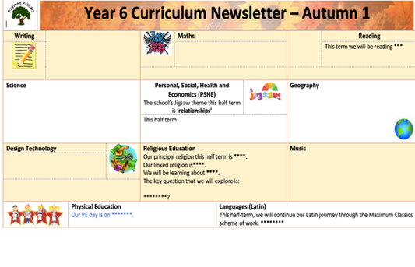 | 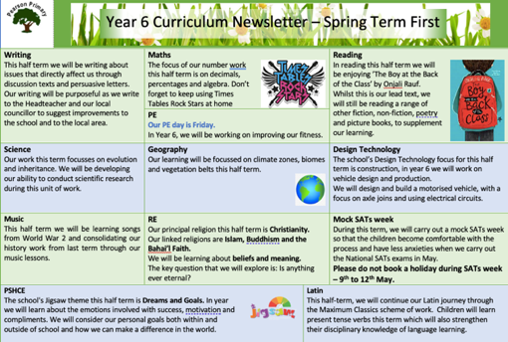 | 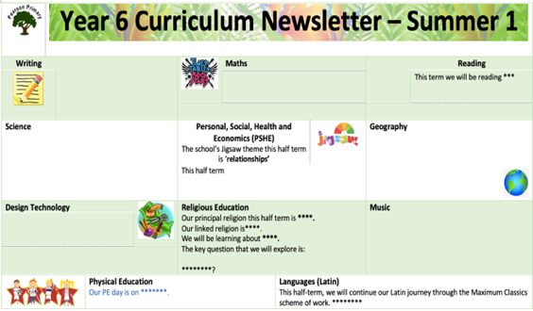
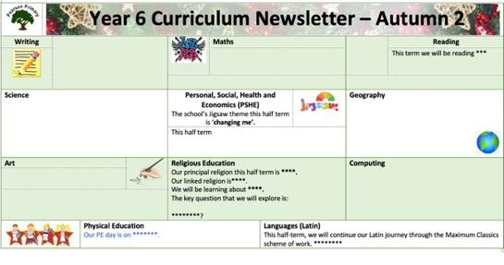 | 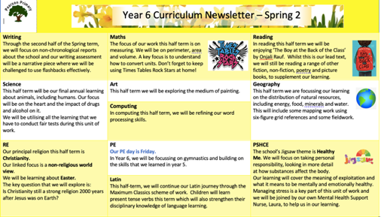 | 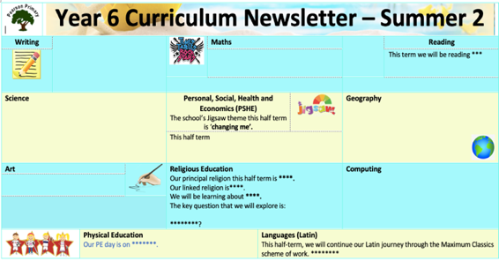

What can I do to help my child?

- Learning is a social act and communicating is the first key to learning. Talking with your child about the world around them will support them in their learning above anything else.

- Reading is the second key to the curriculum. Until your child is reading well enough to access all areas of the curriculum through books, you will receive an additional daily phonics or reading lesson, text directly to your mobile phone, so that they can continue to practise at home. Encouraging children to read is the best piece of advice that we can give you. Get hold of as many books as possible that interest your child and READ, READ, READ!

