Dear Parents

We are launching Microsoft Teams in Upper Key Stage 2. Children in Year 5 and 6 are being given login details so they are able to access Microsoft Teams from home. If we were to close a bubble or close the whole school children will access their learning via the Teams platform. In this situation, we will have the ability to teach some lessons virtually each day and the children will be given different activities to complete alongside these.

Each child will be shown how to log in and access materials on Teams but I have included some step by step instructions so you can support your child if needed.

Step 1: Type Microsoft teams into your search bar or on Google

Step 2: Click the link.

Step 3: Click Sign in.

Step 4: Enter the username you have been given, click Next and then enter the password. Click Sign in.

Step 5: You will be given an option to download the teams app onto your device to make access quicker in the future or to continue on the web.
Click here to continue using the web version
Click here to download the app on your device

Step 6: Click the team for your class

Click here to see the latest activity for the team.

Click this to enter your team. It will say your class name.

Click here to see your assignments

Step 6: On the main page you should see the work you have been assigned. Click View assignment. You can also see this on the Assignments tab on the task bar.

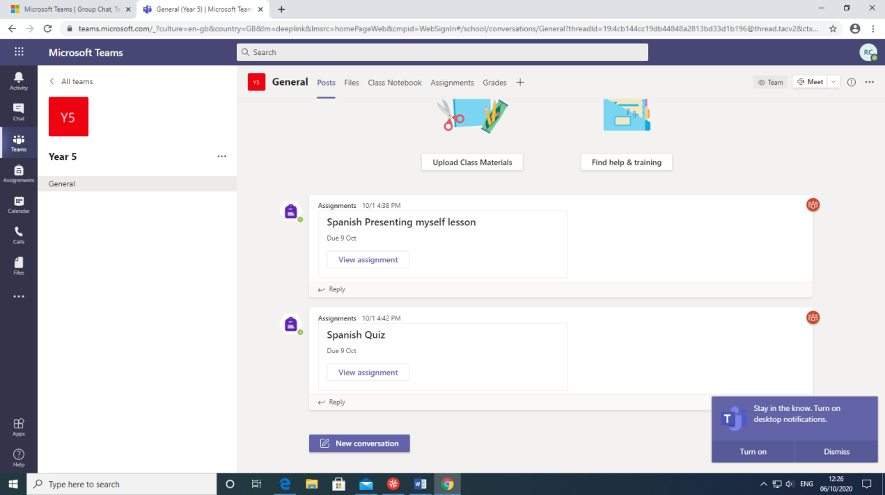

Step 7: Read the instructions from the teacher and click the links to open the documents
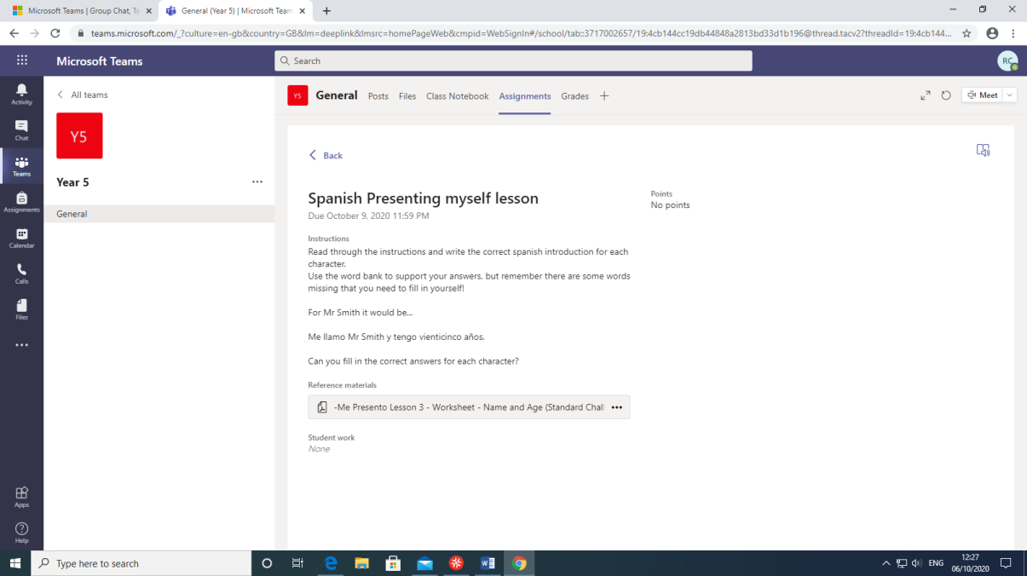

Step 8: Complete the work and click Submit if it is a quiz or hand in if it is a file.

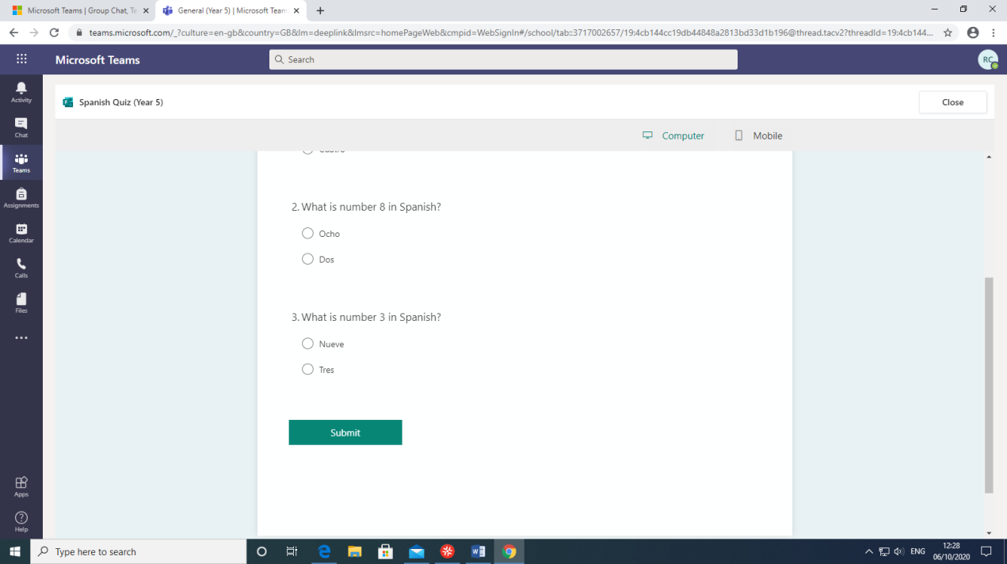

If you have any questions please contact us via the chat function on Teams, via email or via Class Dojo Messenger.

