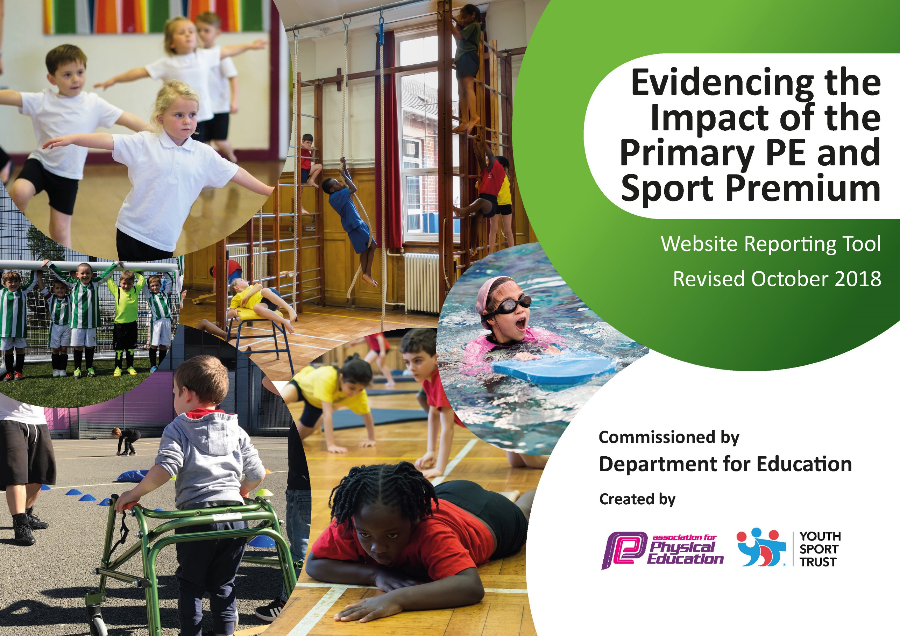
Spending Plan for 2019/20
Interim review – pending full review Spring 2020/21
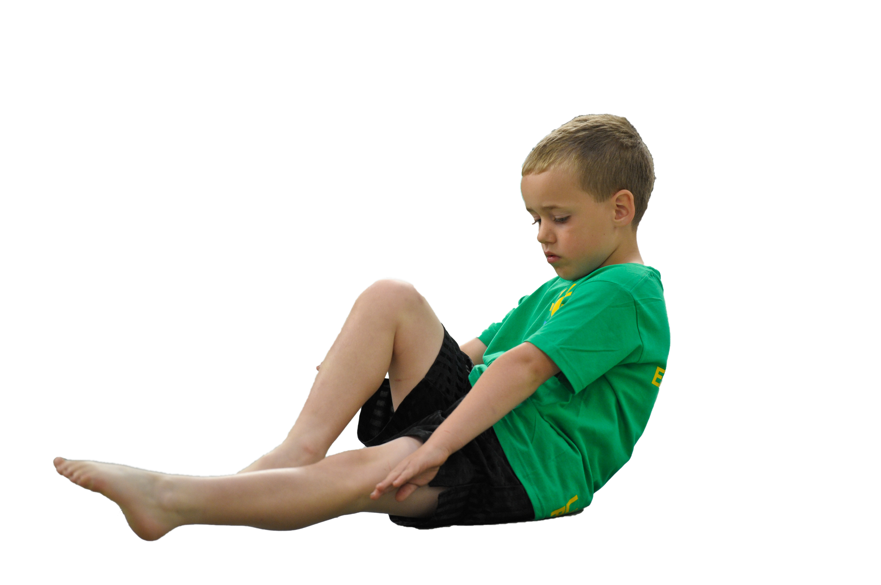
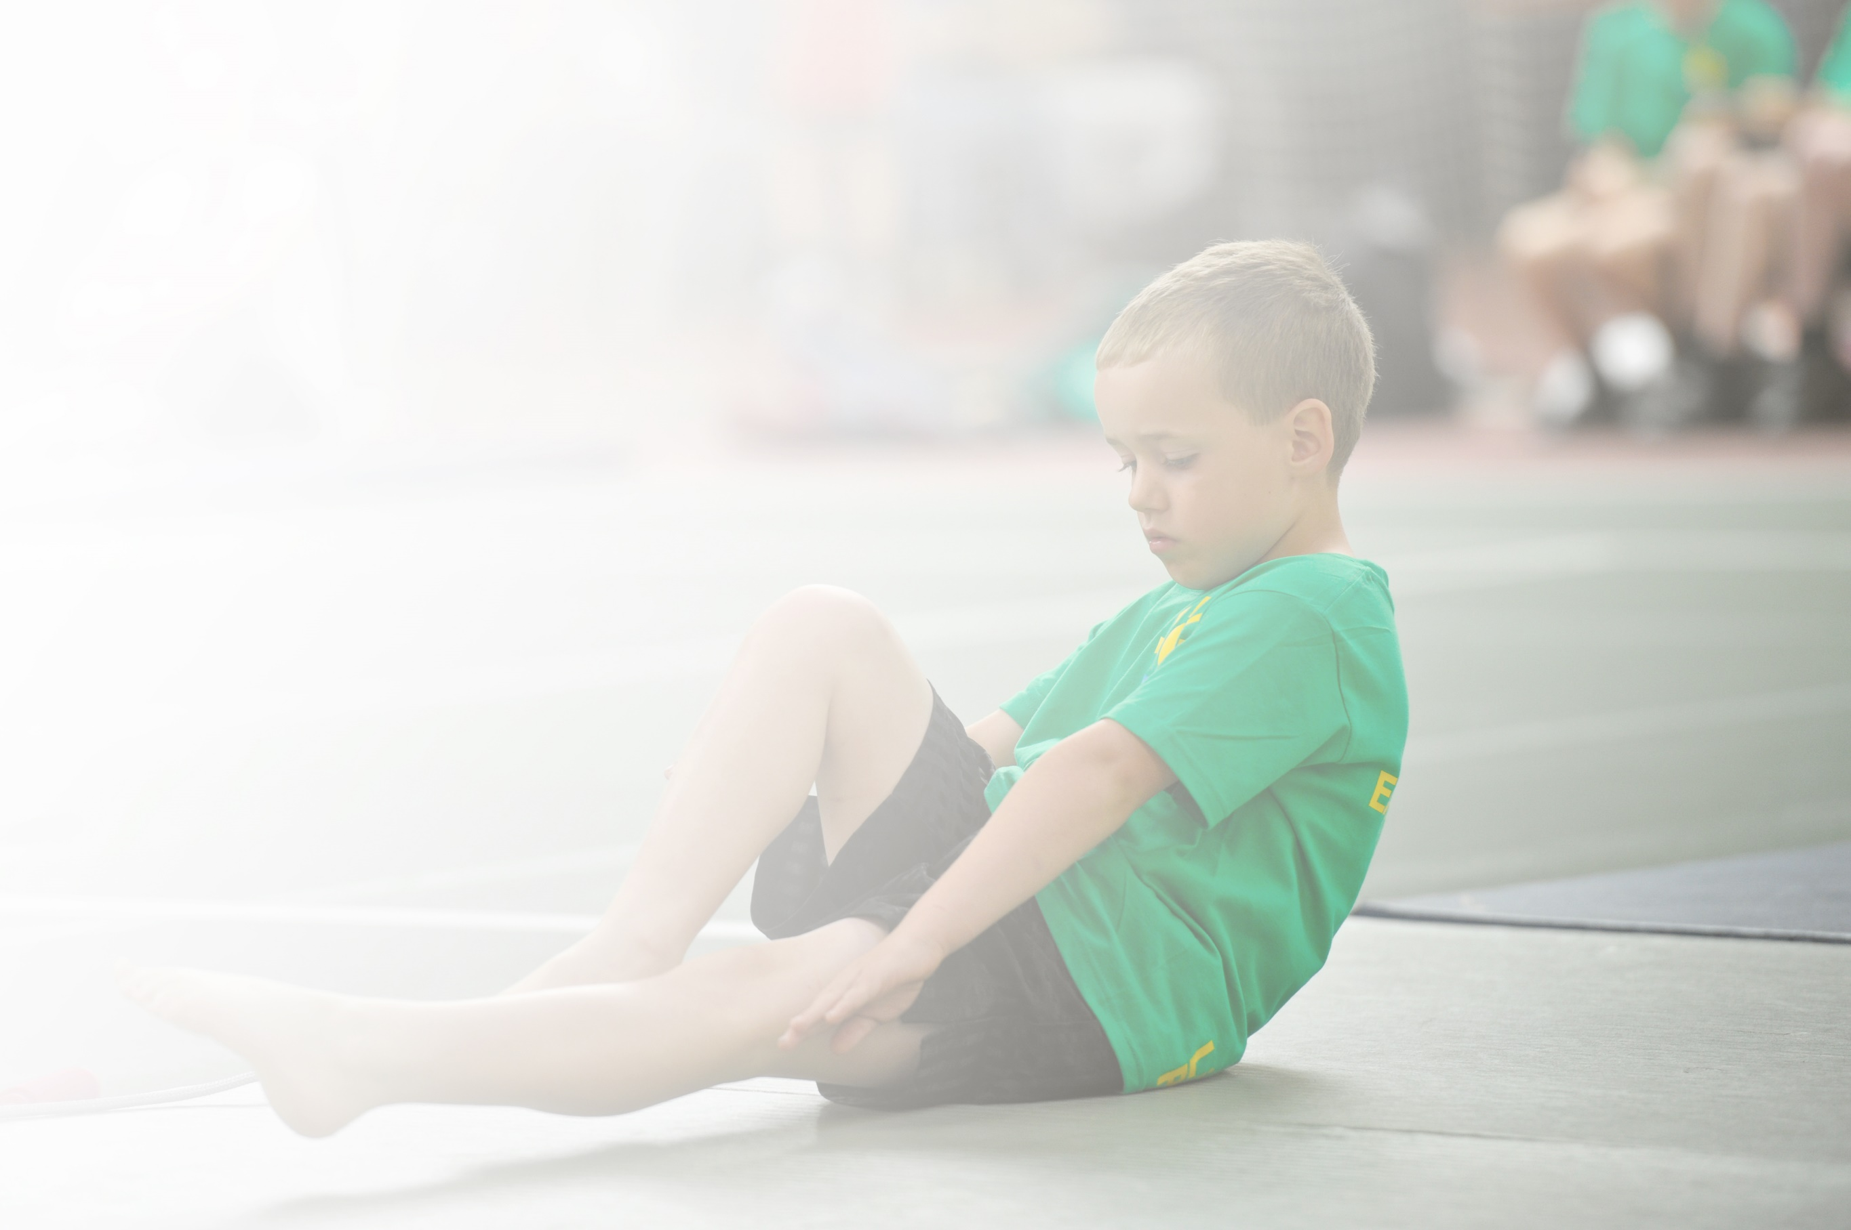
Schools must use the funding to make additional and sustainable improvements to the quality of Physical Education, Sport and Physical Activity (PESPA) they offer. This means that you should use the Primary PE and Sport Premium to:

- Develop or add to the PESPA activities that your school already offer
- Build capacity and capability within the school to ensure that improvements made now will benefit pupils joining the school in future years

Please visit gov.uk for the revised DfE guidance including the 5 key indicators across which schools should demonstrate an improvement. This document will help you to review your provision and to report
your spend. DfE encourages schools to use this template as an effective way of meeting the reporting requirements of the Primary PE and Sport Premium.

We recommend you start by reflecting on the impact of current provision and reviewing the previous
spend. Under the Ofsted Schools Inspection Framework, inspectors will assess how effectively leaders use the Primary PE and Sport Premium and measure its impact on outcomes for pupils, and how effectively governors hold them to account for this.

Schools are required to publish details of how they spend this funding as well as on the impact it has on pupils’ PE and sport participation and attainment by the end of the summer term or by 31 July 2020 at the
latest.
We recommend regularly updating the table and publishing it
on your website throughout the year, as evidence of your
ongoing review into how you are using the money to
secure maximum, sustainable impact. To see an
example of how to complete the table please
click HERE.

Support for review and reflection - considering the 5 key indicators from DfE, what development needs are a priority for your setting and your students now and why? Use the space below to reflect on previous spend, identify current need and priorities for the future.

Key achievements to date: | Areas for further improvement and baseline evidence of need:
- Gold School Games Mark for the first time, 2018/19  - Development of playground play-park over three years, and outdoor covered area.  - Replacement/modernising of gymnastics equipment.  - Continued attendance at Hull Active Schools sports competitions and events.  - Extra provision of Swimming lessons – children now have 30 hours swimming at Pearson, compared previously with 10 hours.  - Swimming attainment – more children achieving expected standard in Y4 than at Y4 (the previous swimming end point) | - Implement “big ideas” / key concepts in PE lessons (healthy me, leading me)  - Increase staff confidence in PE teaching, particularly in gymnastics and games.  - Increase opportunity for pupils to lead physical activity (either within taught lessons, or playtimes)  - Develop provision for moving/handling in Foundation Stage (approx. two-thirds of pupils enter school at F2 below nat. exp. standards)  - Continue to provide increased access to physical activity for identified less active pupils.

Meeting national curriculum requirements for swimming and water safety | Please complete all of the below:
What percentage of your current Year 6 cohort swim competently, confidently and proficiently over a distance of at least 25 metres?  N.B. Even though your children may swim in another year please report on their attainment on leaving  primary school. | 24%
What percentage of your current Year 6 cohort use a range of strokes effectively [for example, front crawl, backstroke and breaststroke]? | 52%
What percentage of your current Year 6 cohort perform safe self-rescue in different water-based situations? | 52% This class have had 20 hours swimming. Future classes will have 30 hours.
Schools can choose to use the Primary PE and Sport Premium to provide additional provision for swimming but this must be for activity over and above the national curriculum requirements. Have you used it in this way? | Yes/No

Action Plan and Budget Tracking
Capture your intended annual spend against the 5 key indicators. Clarify the success criteria and evidence of impact that you intend to measure to evaluate for students today and for the future.

Academic Year: 2019/20 | Total fund allocated: £17,760 | Date Updated: 14-11-19
Key indicator 1: The engagement of all pupils in regular physical activity – Chief Medical Officer guidelines recommend that primary school children undertake at least 30 minutes of physical activity a day in school |  |  |  | Percentage of total allocation:
 |  |  |  | 8%
School focus with clarity on intended impact on pupils: | Actions to achieve: | Funding allocated: | Evidence and impact: | Sustainability and suggested next steps:
- Increase opportunity for pupils to lead physical activity (either within taught lessons, or playtimes)  - Develop provision for moving/handling in Foundation Stage (approx. two-thirds of pupils enter school at F2 below nat. exp. standards)  - Continue to provide increased access to physical activity for identified less active pupils. | - Additional High Intensity physical sessions (ie. Joe Wicks fitness sessions)  - Establish daily running sessions.  - Investigate possibility of physical activity provision in classroom lessons (ie. Physical maths/literacy)  - Monitor physical activity of groups of children and target provision as needed. Utilise “family groups” to support targeted provision. | £1500 teacher release | Y3/4 and Y5/6 exercise routine sessions 1x weekly (Fri) = 15 to 20min High Intensity  Staff training course now available and to be arranged.  Weekly “Change 4 Life” session – VH + CR lunchtime – two groups, once weekly.  Children identified and targeted to miss no HIIT sessions mentioned above for interventions. | Ensure implementation of missed opportunities due to educational interruption as a result of COVID-19.  Review impact of spending by end of Spring Term 2021 to inform future spending for 2020/21
Key indicator 2: The profile of PE, Sport and Physical Activity being raised across the school as a tool for whole school improvement |  |  |  | Percentage of total allocation:
 |  |  |  | 11%
School focus with clarity on intended impact on pupils: | Actions to achieve: | Funding allocated: | Evidence and impact: | Sustainability and suggested next steps:
- Create lasting experiences that will inspire and motivate pupils to commit to a lifelong involvement in physical activity | - In-school competition.  - Hull Schools’ competition.  - Sport Relief Mile event.  - School Games Week.  - Greater swimming provision  - Bikeability  - After-school clubs  - Sports coaches  - Welcoming Sports Clubs into school to lead clubs/PE (Eg. Hull FC, Hull City AFC, Yorkshire CCC) | £1500 St Marys (Hull Active Schools, administered by St Mary’s School Sports co-ordinator)  £2000 additional swimming | Inter-class (by phase) competition for Spring to be planned and scheduled.  Currently been unable to schedule due to knock-on effect of refurbishment of Ennerdale, impacting on Bev Rd Baths.  CK trying again to organise now Ennerdale re-opened.  Hull FC, Hull YPI Tennis.  Table tennis contacted to organise/book. | Ensure implementation of missed opportunities due to educational interruption as a result of COVID-19.  Review impact of spending by end of Spring Term 2021 to inform future spending for 2020/21

Key indicator 3: Increased confidence, knowledge and skills of all staff in teaching PE and sport |  |  |  | Percentage of total allocation:
 |  |  |  | 16%
School focus with clarity on intended  impact on pupils: | Actions to achieve: | Funding  allocated: | Evidence and impact: | Sustainability and suggested  next steps:
- Develop the quality of PE teaching.  - Develop progression in PE.  - Increase staff confidence in PE teaching, particularly in gymnastics and games. | - Implement “big ideas” / key concepts in PE lessons (healthy me, leading me)  - Lesson drop-ins and bespoke PDP for all teachers.  - Develop evidence base of Big Ideas.  - Investigate needs of EYFS PE staff training/schemes of work (training for new staff member and ASA’s).  - Investigate new PE scheme of work for EYFS, KS1 and KS2. | £3000 | YST teacher training scheduled for APRIL – re BIG IDEAS.  Spring 2  ‘Pupil Leadership’ evidence in progress on SeeSaw.  EYFS provision – spent £X resourcing physical development.  EYFS/Teacher training offered early spring but unable to release. More sought.  TBA | Ensure implementation of missed opportunities due to educational interruption as a result of COVID-19.  Review impact of spending by end of Spring Term 2021 to inform future spending for 2020/21
Key indicator 4: Broader experience of a range of sports and activities offered to all pupils |  |  |  | Percentage of total allocation:
 |  |  |  | 54%
School focus with clarity on intended  impact on pupils: | Actions to achieve: | Funding  allocated: | Evidence and impact: | Sustainability and suggested  next steps:
Additional achievements:  - Develop provision for moving/handling in Foundation Stage (approx. two-thirds of pupils enter school at F2 below nat. exp. standards)  - Utilise offers from professional sports organisations/teams (Hull RC, Yorkshire CCC etc) in leading blocks of class PE.  - Access to Hull Active Schools competition and festivals for wide ability of pupils.  - Provide extra curricular sport /activity club | - Investigate ways to develop our foundation stage play area and purchase resources/equipment accordingly.  - PE lessons led by professional clubs eg. Hull FC in the community, Rising Stars Cricket (Yorks. CCC) etc.  - Bikeability/pedestrian skills.  - Extra swimming lessons (30 hours instead of 10hours)  - School teams to take part in in-school competition, competition against local schools and competition against Hull schools through HAS, including festivals and competition for low-ability/less-active/SEN pupils.  Individual Personal Best competition (eg. Running, athletics decathlon)  - After-school clubs/breakfast sports clubs.  - Residential activity Weekend at PGL | £2500 resources  £2700  £2000  £1500  £2700  £600  £2000 subsidised | £X spend resourcing physical development resources  Hull FC, Hull YPI tennis.  Table tennis in pipeline.  Feb 25/26th 2020  See above  Football events x4  Cross Country  Athletics  Cluster S.R. Mile (Mar 12th)  Tennis events Hull YPI x 2 (Summer)  Cluster Kwik Cricket (Summer)  Cluster Netball/Benchball (Spring/Summer)  HAS Orienteering (Summer)  HAS Boccia (C4L)  HAS Kurling (C4L)  C4L events between local schools to schedule at local cluster meeting,  After school sports clubs, and provision for, ongoing and scheduled. Breakfast Club – seeking Table tennis.  PGL Caythorpe Court Booked for Sept 2020 | Ensure implementation of missed opportunities due to educational interruption as a result of COVID-19.  Review impact of spending by end of Spring Term 2021 to inform future spending for 2020/21
Key indicator 5: Increased participation in competitive sport |  |  |  | Percentage of total allocation:
 |  |  |  | 11%
School focus with clarity on intended  impact on pupils: | Actions to achieve: | Funding  allocated: | Evidence and impact: | Sustainability and suggested  next steps:
- More children to be involved in competitive sports across the school | - Intra-school competition x3 yearly.  - Inter-school with local schools (x3 yearly)  - Include individual performance competition (not team-based ie. Athletics, running etc)  - Hull Schools competition through HAS – A and B teams in various competition, including subsidised travel/medals.  - Less-able/SEN to take part in competition (C4L through HAS)  *HAS = Hull Active Schools membership | £1500 St Marys  £2000 | Inter class orienteering, athletics to schedule for late Spring and Summer.  Inter-class Benchball Autumn.  Inter-class XCountry Autumn.  Netball, Cricket and SR mile cluster events.  HAS competition detailed above.  B teams in football, boccia and Orienteering.  C4L events through HAS and with local cluster. | Ensure implementation of missed opportunities due to educational interruption as a result of COVID-19.  Review impact of spending by end of Spring Term 2021 to inform future spending for 2020/21

